

**Agile DataOps**

Year 2 (2025/26)

SCHOOL OF INFOCOMM TECHNOLOGY

Diploma in Data Science

ASSIGNMENT 2

**Duration:** Week 6 to 17 (24 Nov 25 – 13 Feb 26)

**Weightage:** 45% of Module

Format: Individual: 55%

Team: 45%

**Deadlines:**

|  |  |
| --- | --- |
| **Deliverables** | **Date/Time** |
| Project Documentation | 31 Jan 2026 (Sat 23:59 hrs) |
| Presentation | 2 Feb - 13 Feb 2026 |
| Group Members (Group 3) | Ang Shao En, Simon Saw Yong Ping, Jayden Tee Rong Qing, Jerremmy Lee Rasni, Ho Wei Xian |

Penalty for late submission:

* 10% per day (including weekends & public holidays).
* NO late submission shall be accepted after 7th Feb 2026.

2.1: Executive Summary 3

2.2: Project Overview 4

2.3: Data Profiling 6

2.4: Data Cleaning 14

2.4.1 Placeholder Value Remediation 14

2.4.2 Duplicate Detection & Resolution 17

2.5 DataOps Pipeline and Cloud Migration 21

2.5.1 Cloud Platform Selection: Snowflake 21

2.5.2 The Migration Process (ELT & Automation) 23

2.5.3 Data Warehouse Architecture (The Trusted Layer) 27

2.5.4 Channel-Specific Reporting Views 30

2.5.5 Data Warehouse Naming & Structure Standards 32

2.5.6 Consolidation of ELT scripts 35

2.5.7 Bonus Tool Used: Snowflake CLI 36

2.6 CI/CD and Version Control 37

2.7: Dashboard Insights 48

2.7.1 Dashboard Overview 48

2.7.2 Dashboard Utilisation Report for Key Business Roles 65

1. Regional Sales Manager 65

2. Customer Analyst 65

3. Operations Manager 66

4. Product Owner 66

5. Chief Financial Officer (CFO) 67

2.8: Burn Down Charts by Sprint 68

Sprint 1: Foundation & Setup 68

Sprint 2: Ingestion & Modeling 69

Sprint 3: Trusted Reporting Layer 70

Sprint 4: Business Intelligence & Dashboarding 71

Sprint 5: Final Report & Presentation 72

2.9: Challenges and Solutions 73

Technical Challenge 1: Snowflake 2FA & Power BI Connectivity 73

Technical Challenge 2: Mitigating Row Inflation & Revenue Discrepancies 73

Technical Challenge 3: GitHub Access Control and Repository Governance 74

Team Dynamic Challenge: Task Dependencies in Thematic Sprints 75

Problem-Solving Approach 75

2.10: Reflection and Lessons Learned 76

Agile Methodology 76

Personal and Team Growth 76

Future Applications 76

2.11 Conclusion 77

2.12. References 78

# 2.1: Executive Summary

**Objectives:**The primary objective of this project was to modernize Contoso Ltd’s aging on-premises SQL Server infrastructure, which had become a critical bottleneck for the company’s expansion into the South East Asia (SEA) region. Facing performance degradation, fragmented regional data, and query timeouts on millions of transaction rows, management tasked the DataOps team with three key goals: 1) Achieve infinite scalability by migrating to the cloud, 2) Unify siloed regional data into a "Single Source of Truth," and 3) Enable zero-latency reporting to drive agile decision-making across omni-channel operations.

**Solution Overview:**The team implemented a comprehensive DataOps solution centered on migrating the Contoso Retail dataset to **Snowflake**, leveraging its multi-cluster architecture to separate storage from compute resources. We engineered a robust **Star Schema** within the data warehouse to optimize analytical performance and established an efficient ELT (Extract, Load, Transform) pipeline to handle high-volume transactions. The solution culminated in the deployment of role-specific **Power BI** dashboards connected via **DirectQuery**, ensuring that regional managers and executives access live, un-cached data for real-time performance tracking.

**Key Results:**

* **Infrastructure Modernization:** Successfully migrated millions of sales records to Snowflake, decoupling heavy analytical workloads from operational systems and eliminating query timeouts.
* **Real-Time Insights:** Reduced reporting latency from days to seconds, allowing SEA regional managers to benchmark store performance and inventory levels instantly.
* **Strategic Optimization:** The new analytics capability immediately identified critical business opportunities, including a **57.62%** aggregate profit margin driver in Home Appliances and specific "dead stock" (legacy MP3/DVDs) candidates for liquidation, enabling data-driven inventory rationalization.

This transformation positions Contoso to execute its SEA expansion strategy with data-driven confidence, establishing a scalable foundation for future regional growth.

# 2.2: Project Overview

**Background:**   
Contoso Ltd is a large global retail conglomerate selling electronics and home appliances through a vast network of physical stores and online channels. Currently, Contoso relies on a legacy **on-premises SQL Server** system that houses millions of transaction records from its global operations.

This aging infrastructure is struggling to handle the company's massive data volume (over 100,000+ products and millions of sales rows). The system faces severe **performance bottlenecks**, particularly when regional managers in South East Asia (SEA) attempt to run complex analytical queries to benchmark their performance against global standards. To support its aggressive expansion in the SEA region, Contoso has tasked your DataOps team with modernizing their data infrastructure by migrating to **Snowflake**, a scalable cloud-based platform.

**Key Reporting Needs:**   
Contoso’s leadership requires specific insights to drive their SEA expansion strategy, generated from the new cloud data warehouse:

1. **Regional Sales Overview (Omni-channel):** Tracks product demand across physical stores and online channels, with a specific focus on comparing **South East Asia** market performance against global trends to identify growth opportunities.
2. **Sales Agent Performance:** Monitors individual employee performance across retail outlets (e.g., Singapore, Bangkok) to manage commissions and identify top talent in the region.
3. **Inventory & Manufacturer Analysis (Supplier Reporting):** Analyzes order volumes and relationships with key brands (Manufacturers) to optimize supply chain efficiency for distributed SEA warehouses.
4. **Customer Segmentation:** Offers granular insights into consumer demographics and purchasing habits within the SEA region to tailor local marketing campaigns.

**Current Pain Points:**   
Contoso currently faces the following challenges:

* **Performance Degradation:** The sheer volume of the FactSales and FactOnlineSales tables causes heavy analytical queries to freeze or time out, slowing down daily transaction processing.
* **Fragmented Regional Data:** Difficulty in consolidating data from diverse SEA markets (Singapore, Thailand) into a single, unified view for timely reporting.
* **Reporting Delays:** Infrastructure struggles to process millions of rows quickly, resulting in stale data that hinders agile decision-making in the fast-moving electronics market.
* **Other Potential Pain Points:** Complex data integration across multiple currencies/regions, lack of governance over sensitive customer PII, and security risks in the legacy on-prem setup.

**Leadership Aims:**

* **Achieve Scalability:** Transition to Snowflake to effortlessly handle millions of transaction rows and future data growth.
* **Unify Regional Insights:** Create a single source of truth that integrates SEA data with global operations.
* **Increase Efficiency:** Decouple heavy analytical reporting from operational systems to ensure zero downtime.
* **Accelerate Reporting:** Enable real-time dashboards for regional managers to track sales agent and store performance instantly.

**Your Mission:**   
Our team acted as a DataOps consulting group, responsible for designing and implementing a modern, cloud-based data architecture for Contoso. We will need to:

* Migrate the complex **Contoso Retail** dataset (focusing on FactSales, DimGeography, and DimEmployee) to Snowflake.
* Build robust ELT pipelines to handle high-volume transactional data.
* Develop interactive Power BI dashboards that provide actionable insights for the **South East Asia** market.

# 2.3: Data Profiling

**Provide a data dictionary and perform data profiling to understand relationships (primary and foreign keys) within your dataset.**

A data dictionary is a document that describes the structure and meaning of data within a database. It lists each table and column along with details such as data type, description, and key type (PK, FK, or Normal). This helps users understand what the data represents, how tables are related, and how the data should be used. A data dictionary improves data consistency, reduces misunderstandings, and makes it easier for analysts, engineers, and business users to work with the data confidently.

**Data Dictionary**

**RAW_DIMCHANNEL**

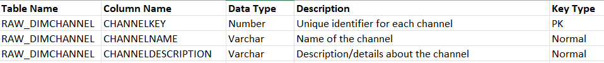

**RAW_DIMCURRENCY**



**RAW_DIMCUSTOMER**

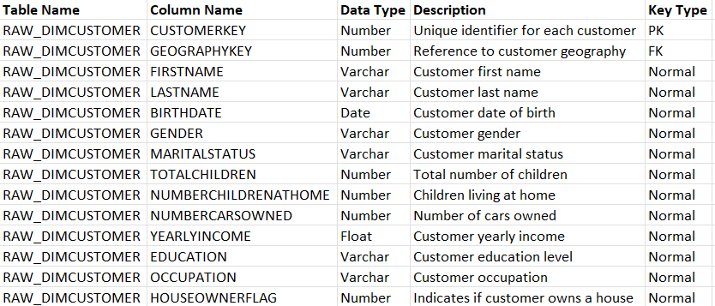

**RAW_DIMDATE**

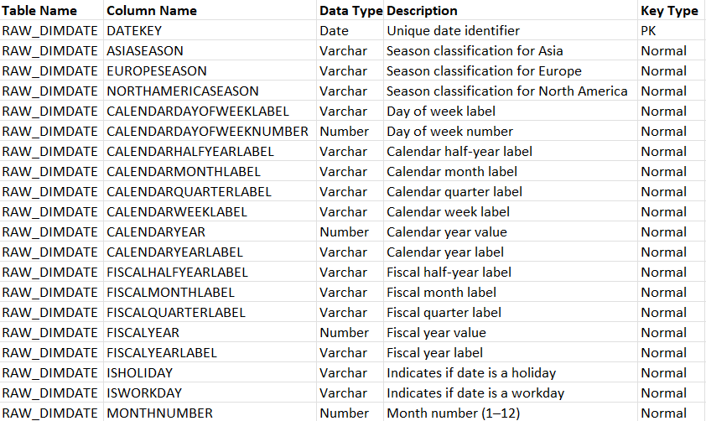

**RAW_DIMEMPLOYEE**

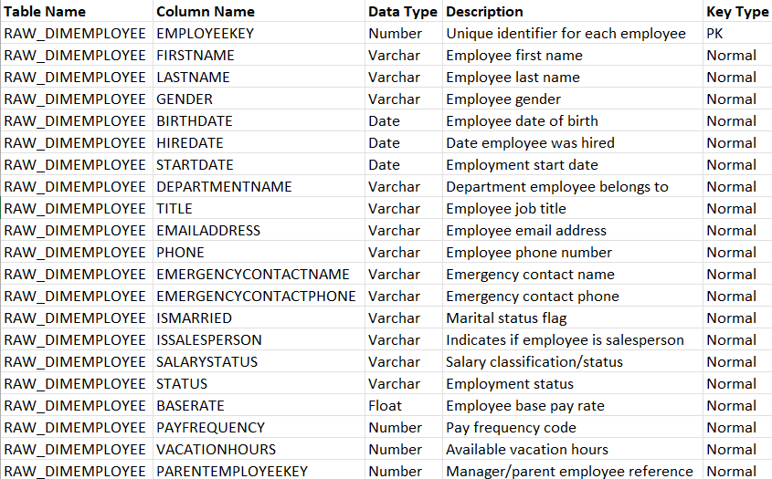

**RAW_DIMGEOGRAPHY**

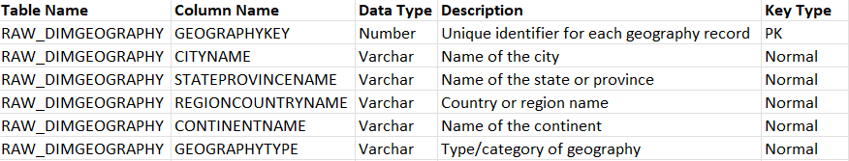

**RAW_DIMPRODUCT**

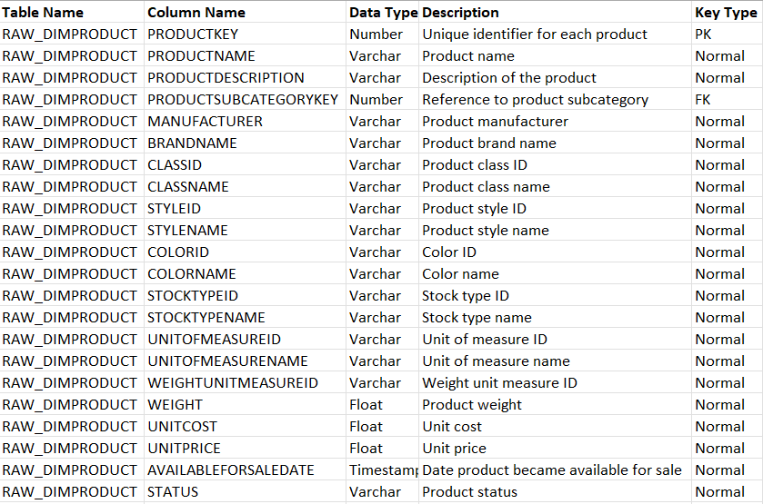

**RAW_DIMPRODUCTCATEGORY**



**RAW_DIMPRODUCTSUBCATEGORY**



**RAW_DIMPROMOTION**

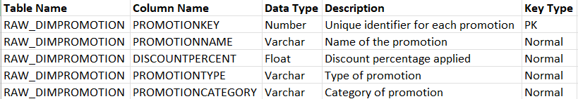

**RAW_DIMSTORE**

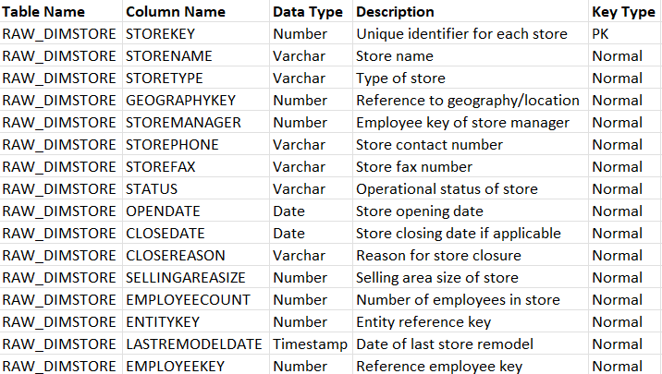

**RAW_FACTSALES**

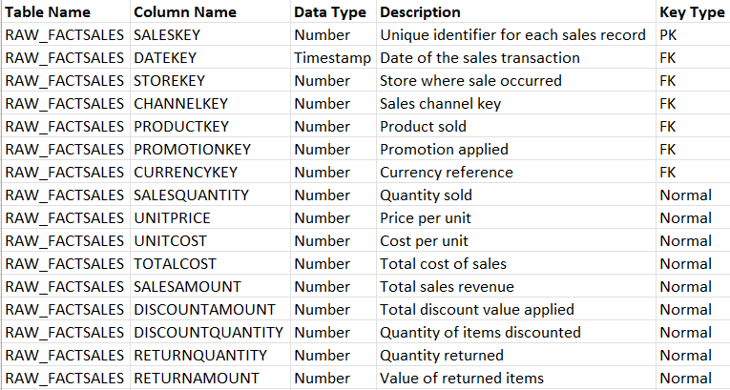

**RAW_FACT_ONLINESALES**

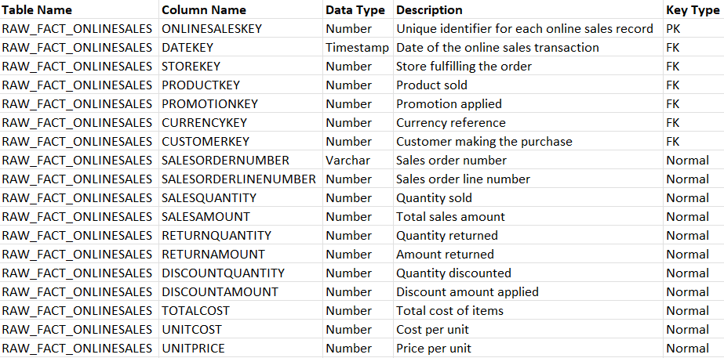

|  |
| --- |
|  |

**VIEW_MASTER_SALES**

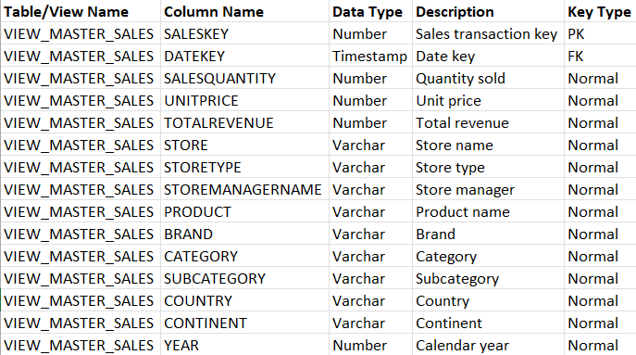

**VIEW_MASTER_ONLINESALES  
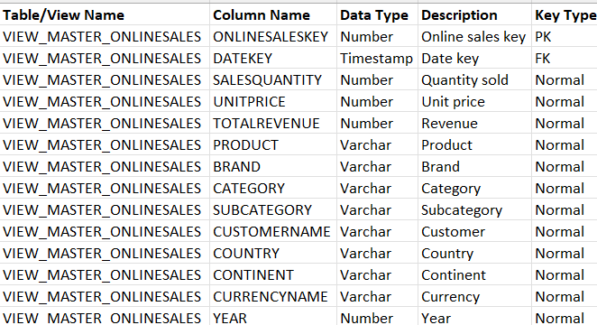**

**VIEW_SEA_PERFORMANCE  
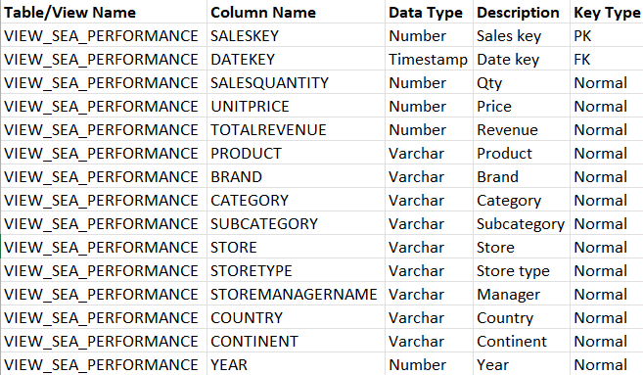**

**VIEW_SEA_ONLINEPERFORMANCE**

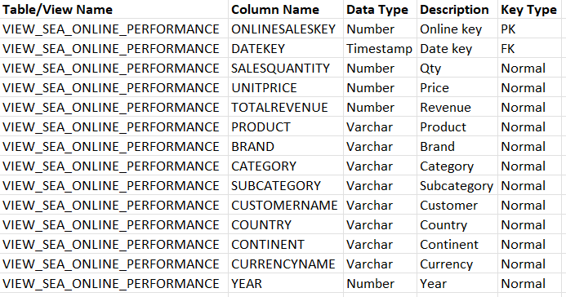

**VIEW_RPT_SALES_MASTER**

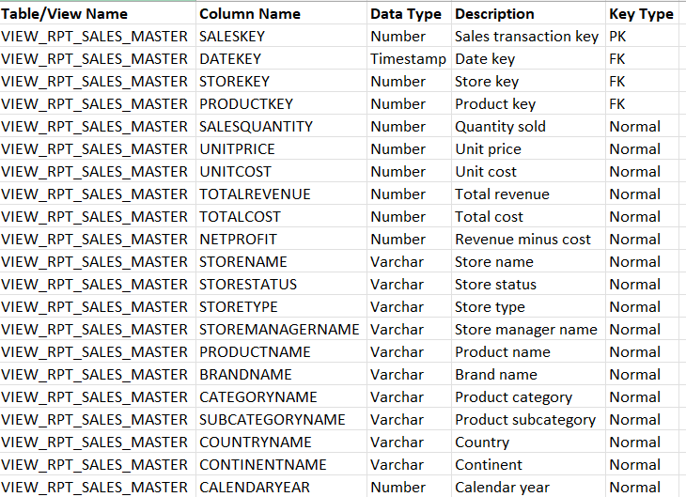

**VIEW_RPT_ONLINESALES_MASTER**

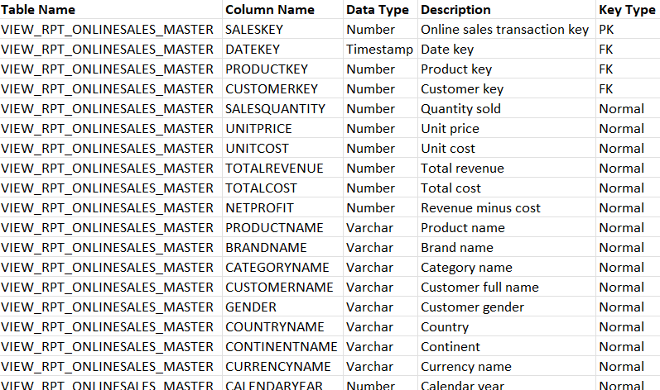

# 2.4: Data Cleaning

## 2.4.1 Placeholder Value Remediation

**Rationale (The Problem):** During the initial data profiling phase (Sprint 1), we identified possible "placeholder" patterns across key dimension tables. For example, missing data was represented variably as "N/A", "Unknown", "0", or simply empty strings ("") within the same column. These inconsistencies pose two major risks to analytics:

1. **Fragmentation:** A bar chart would display separate bars for "N/A" and "Unknown", despite them representing the same concept.
2. **Inaccurate Aggregations:** Empty strings are counted by COUNT(), whereas SQL NULL values are correctly ignored, leading to inflated metrics if not handled.

**Cleaning Logic (The Solution):** To ensure accurate grouping and aggregation, we implemented a standardization rule in the DW_CONTOSO layer. We utilized CASE statements and NULLIF logic to convert all the possible "dirty" placeholder values into standard SQL NULL (or a standardized "Unknown" member for specific dimensions).

The logic applied was:

* **Target:** DimProduct, DimStore, DimCustomer
* **Rule:** IF value IN ('N/A', '0', 'Unknown', '') THEN NULL
* **Benefit:** This allows downstream tools (Power BI) to automatically handle missing data using "Show items with no data" features or explicit DAX handling.

**Results & Validation:** Post-transformation, we verified the data quality by running a profile on the cleaned views.

* **Before:** BrandName contained 4 variations of missing data.
* **After:** All variations have been collapsed into a single NULL bucket.

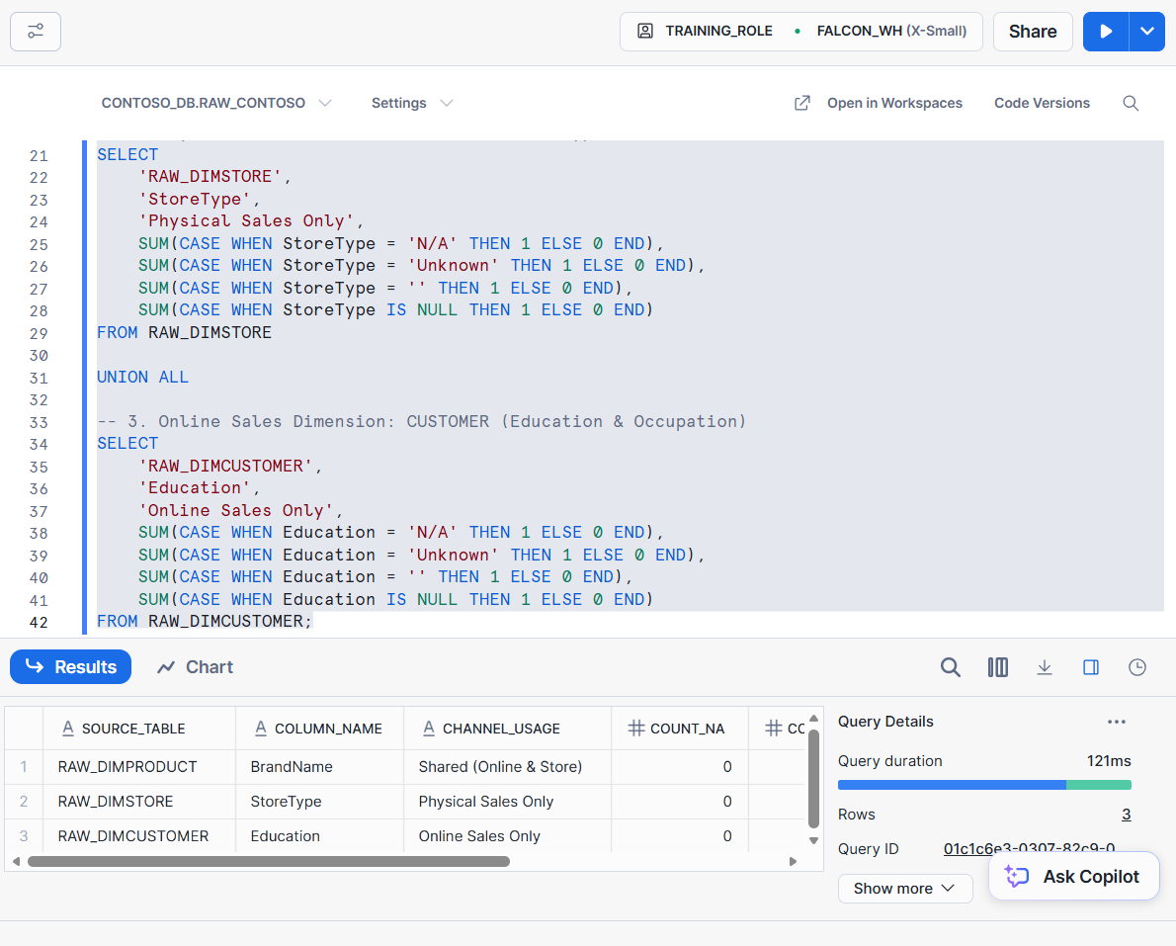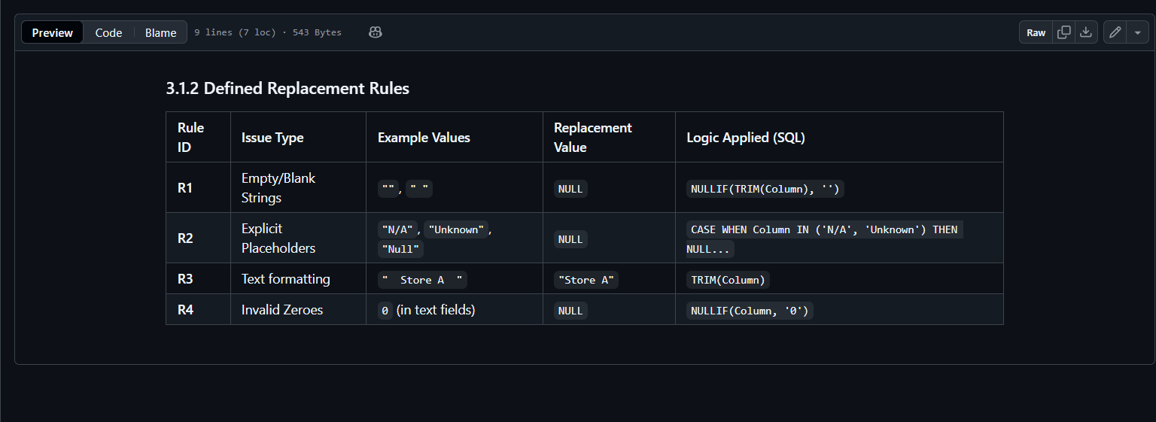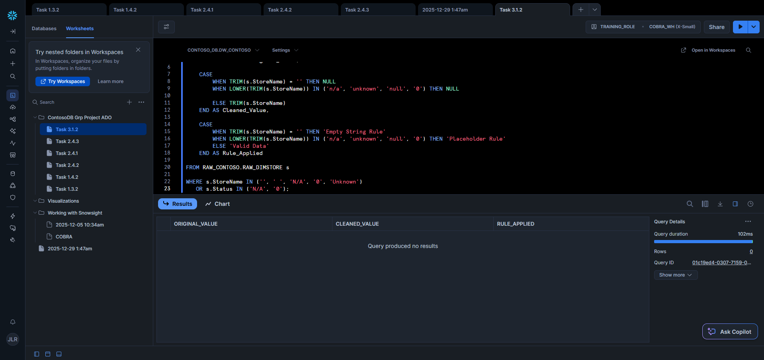

## 2.4.2 Duplicate Detection & Resolution

**Definition**

Deduplication is the process of identifying and removing duplicate records from a dataset to ensure each record is unique and reliable. In data engineering, duplicates commonly arise from repeated data ingestion, system errors, or delayed updates. Applying deduplication ensures that analytics and reporting are based on accurate data.

Quarantine logic refers to isolating suspicious or duplicate records into a separate dataset instead of deleting them immediately. This allows further review and validation before any permanent action is taken.

**Risk of Not Applying Deduplication**

If deduplication is not applied, several risks may occur:

* **Inaccurate reporting** — duplicate records can inflate sales, revenue, or customer counts
* **Poor decision-making** — business insights become unreliable
* **Reduced data quality** — trust in the dataset decreases
* **Operational inefficiency** — analysts spend time resolving inconsistencies
* **Compliance issues** — incorrect records may affect audits or regulatory reporting

Therefore, applying deduplication is critical for maintaining data integrity.

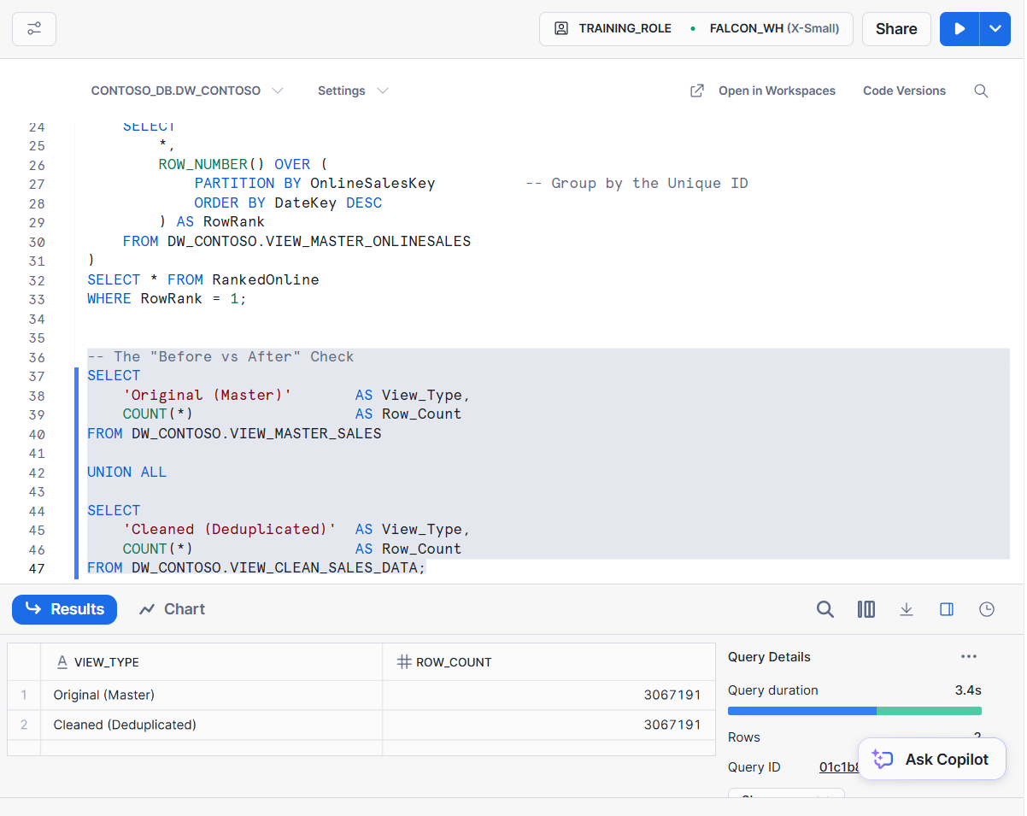

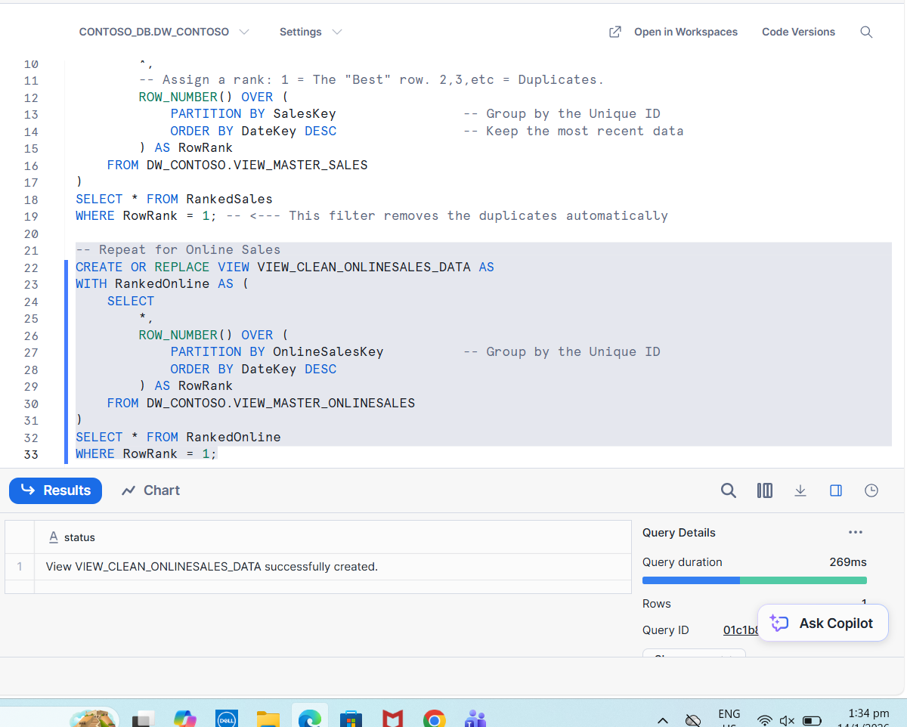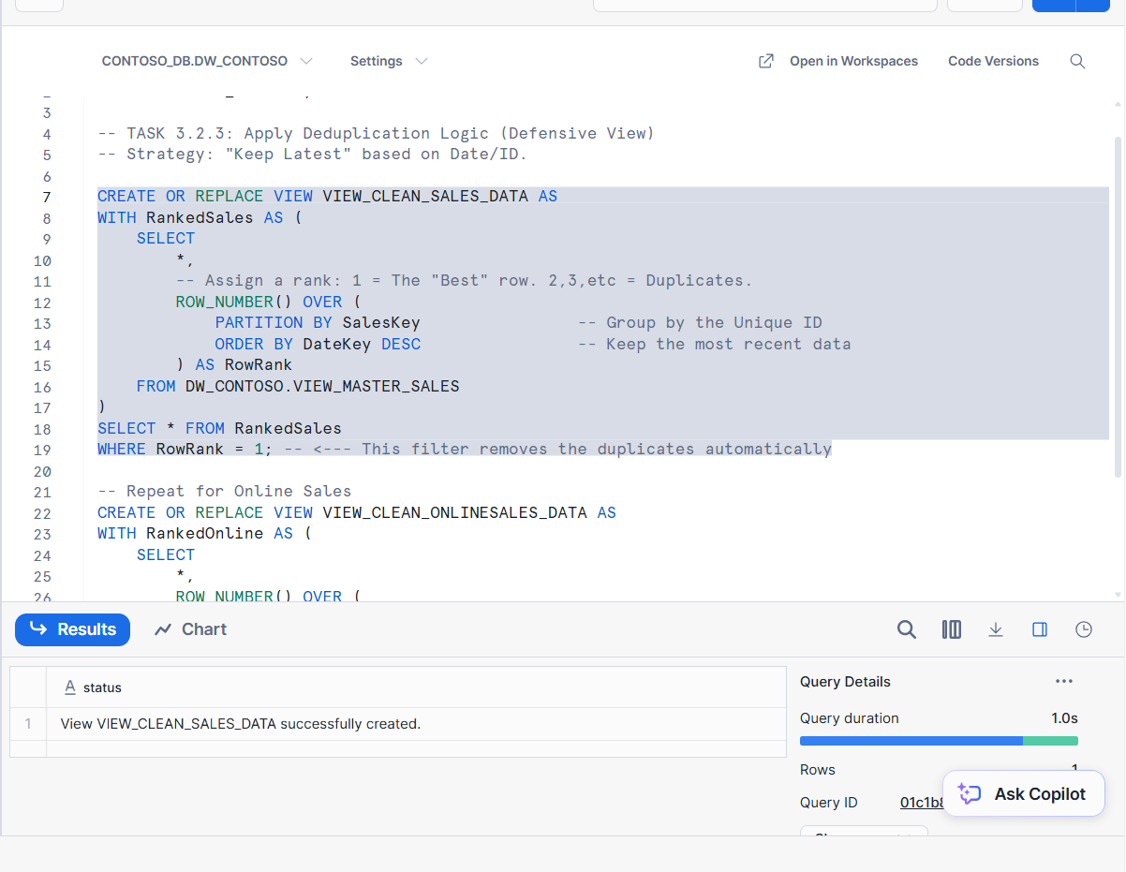

**Step 1: Create Cleaned Views**

Cleaned datasets were stored as views:

* VIEW_CLEAN_SALES_DATA
* VIEW_CLEAN_ONLINESALES_DATA

Using views:

* Preserves original data
* Allows dynamic cleaning
* Enables easy updates
* Follows best practice in data engineering

**Step 2: Validation**

A before-and-after comparison of row counts was conducted to confirm:

* Deduplication logic worked correctly
* No unintended data loss occurred

Conclusion

The deduplication process improved data quality by removing duplicate records and ensuring only the most recent data is used. This enhances reporting accuracy, supports reliable analytics, and ensures better business decision-making.

# 2.5 DataOps Pipeline and Cloud Migration

## 2.5.1 Cloud Platform Selection: Snowflake

Snowflake was selected as the cloud data warehouse platform due to its separation of storage and compute, which directly addresses Contoso’s scalability and performance challenges. This architecture allows analytical workloads to scale independently without impacting data ingestion or operational processes, eliminating query timeouts experienced in the legacy on-premises system. Snowflake’s multi-cluster capability also supports concurrent access by multiple Power BI users, enabling real-time analytics without resource contention.

* **Infrastructure Setup:** We initialized the environment by configuring the database PROJECT_CONTOSO and establishing a layered schema architecture (RAW_CONTOSO for ingestion and DW_CONTOSO for the trusted reporting layer) to ensure a clean separation of duties.
* **Secure Staging:** We utilized Snowflake’s Internal Stages (@CONTOSO_STAGE) to act as the secure landing zone for the raw CSV datasets before ingestion.

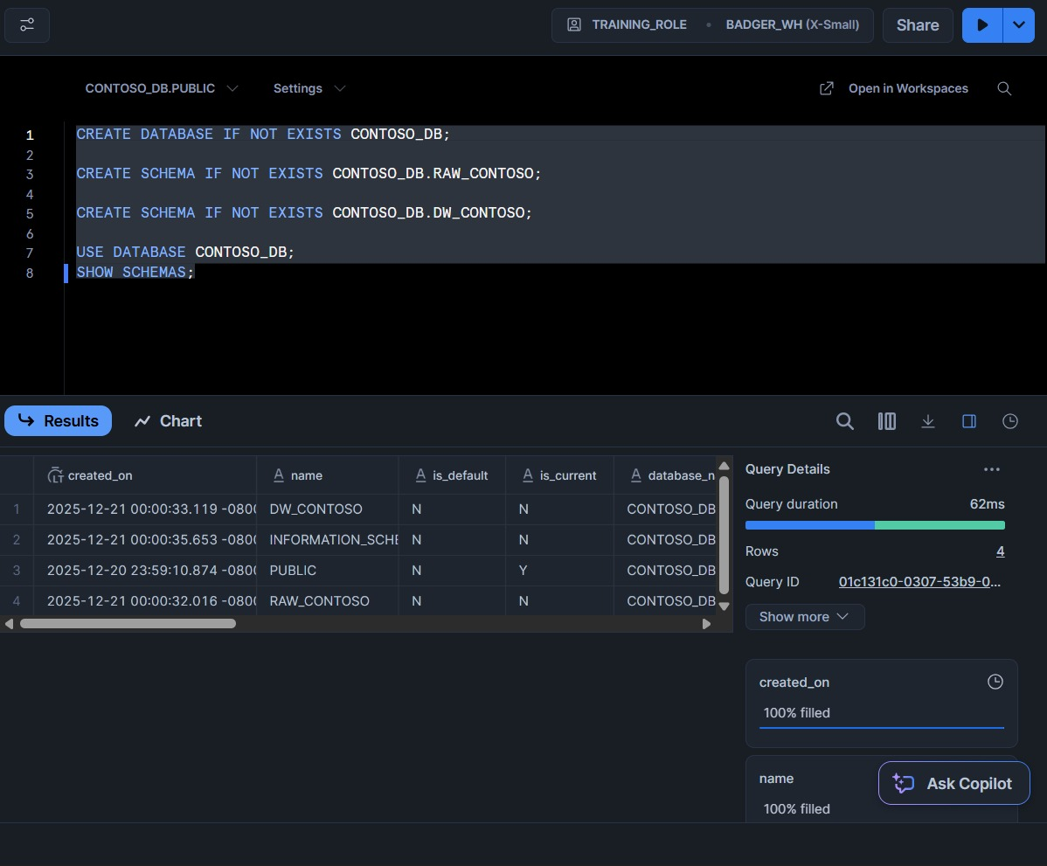

***Figure 1: Infrastructure setup command creating the Raw and DW schemas.***

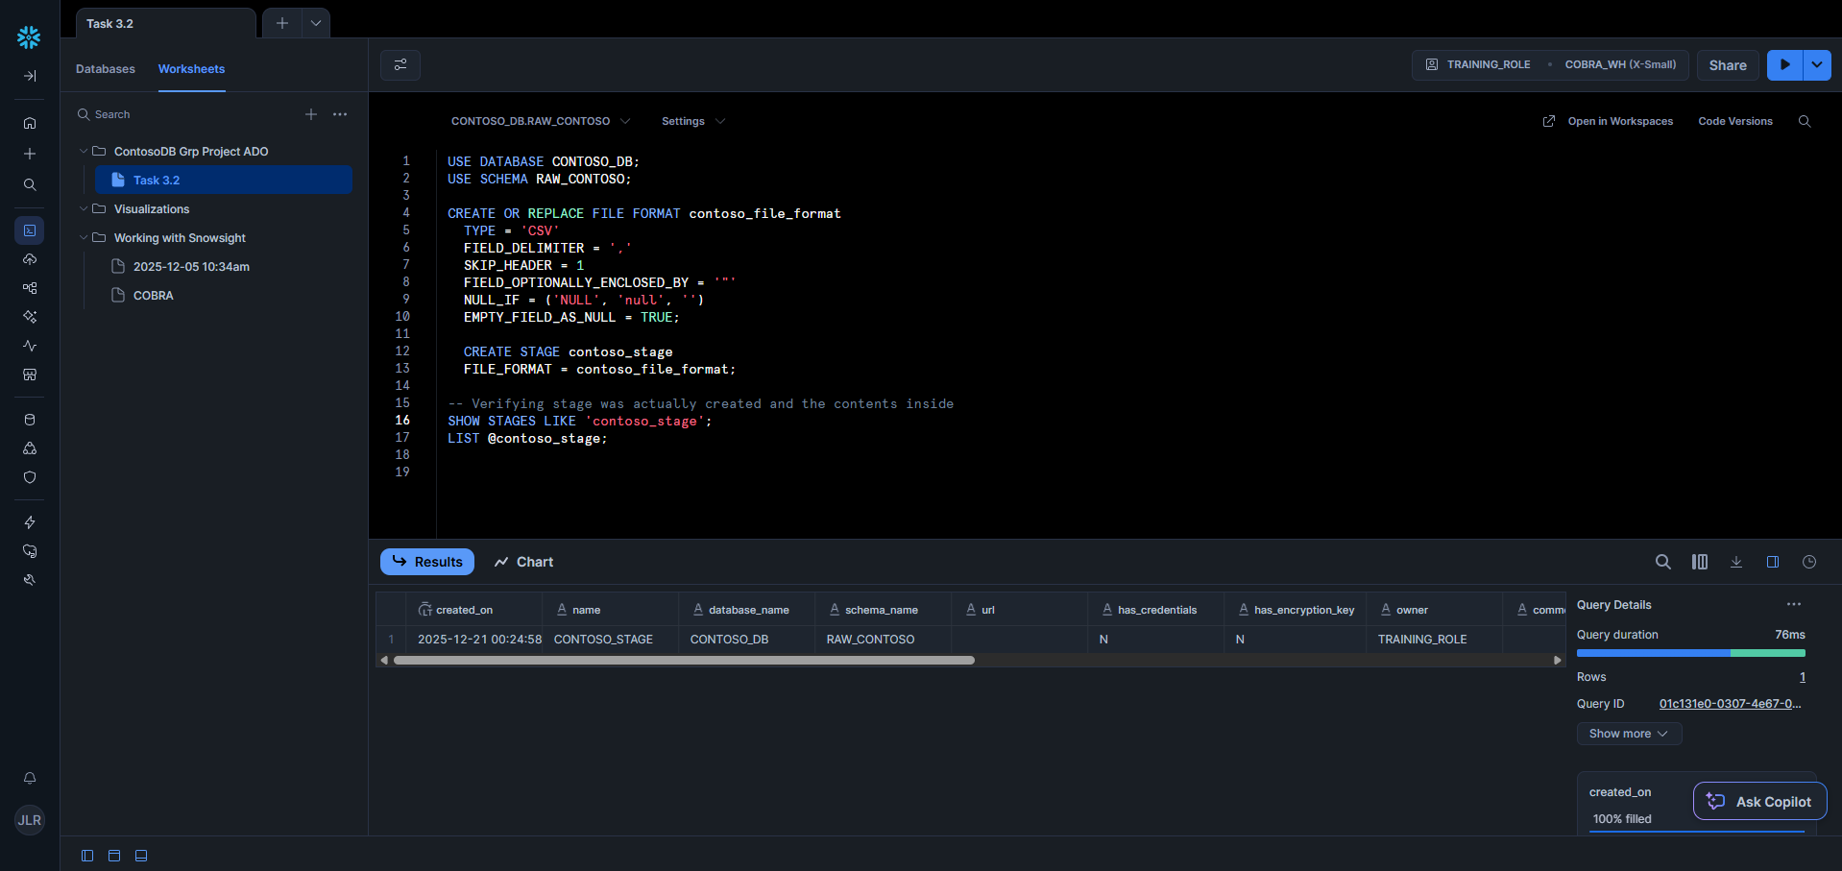

***Figure 2: Configuration of the internal Snowflake stage for secure file loading.***

## 2.5.2 The Migration Process (ELT & Automation)

We implemented a modern **ELT (Extract, Load, Transform)** pipeline, prioritizing loading raw data into the cloud first and using Snowflake’s compute resources for transformations.

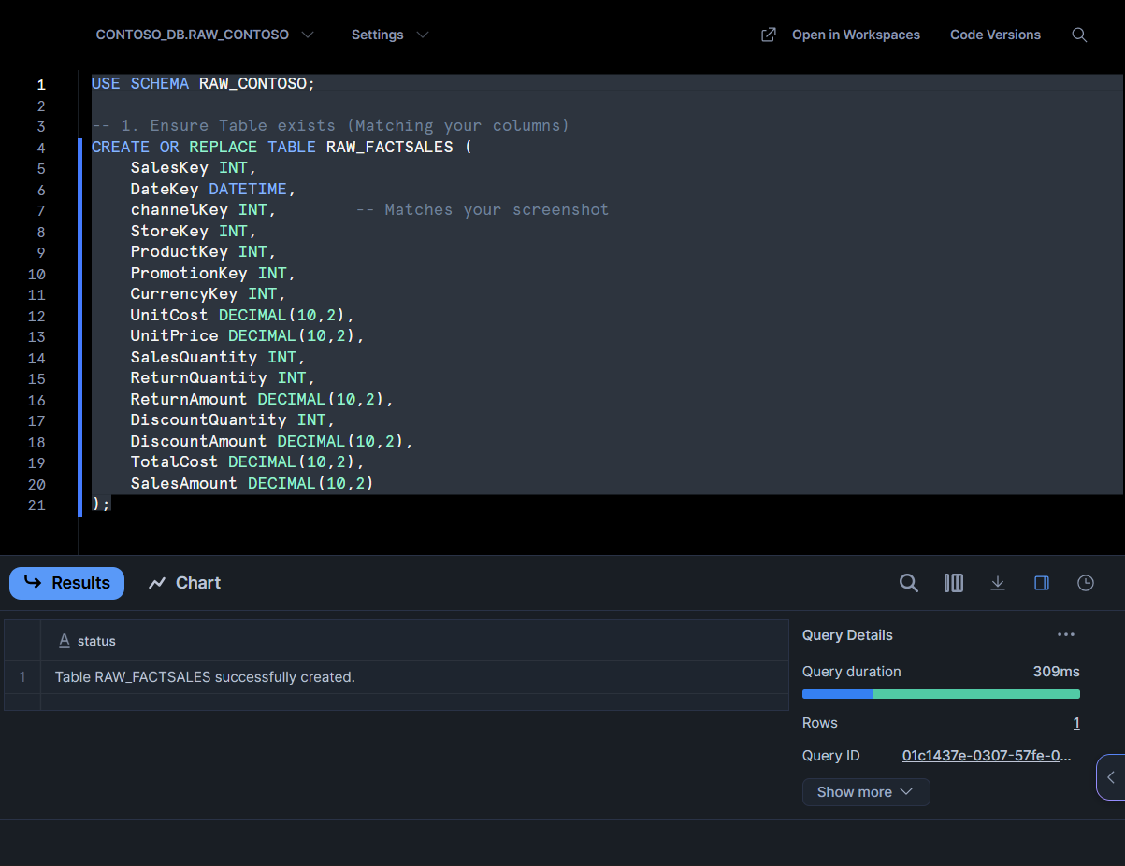

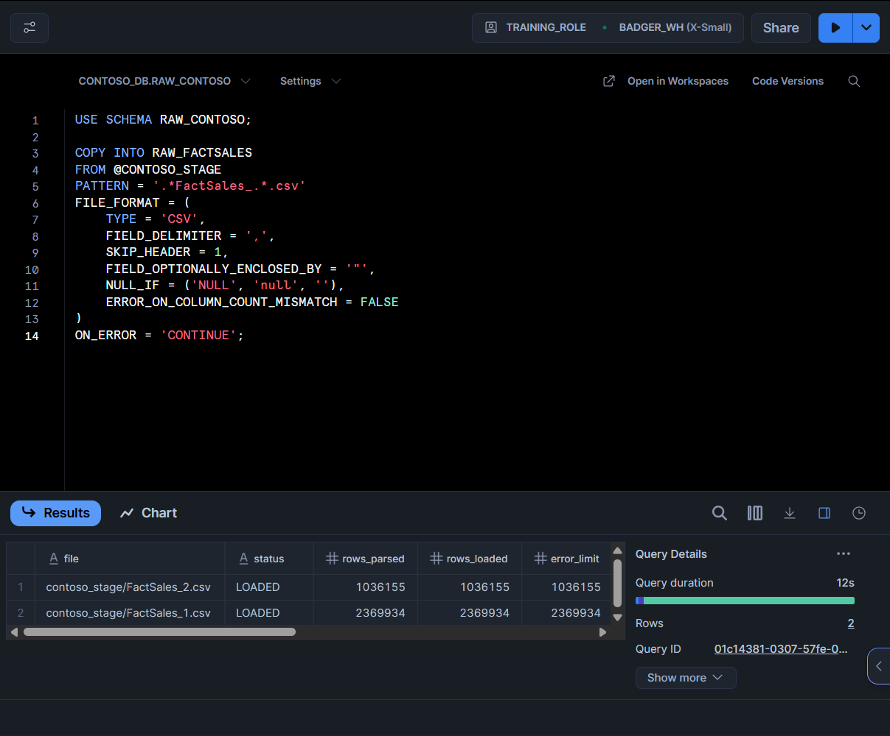

***Figure 3,4: ELT Ingestion script loading millions of rows into FactSales.***

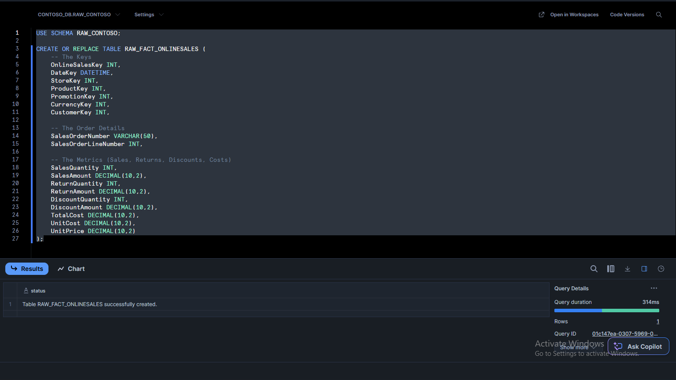

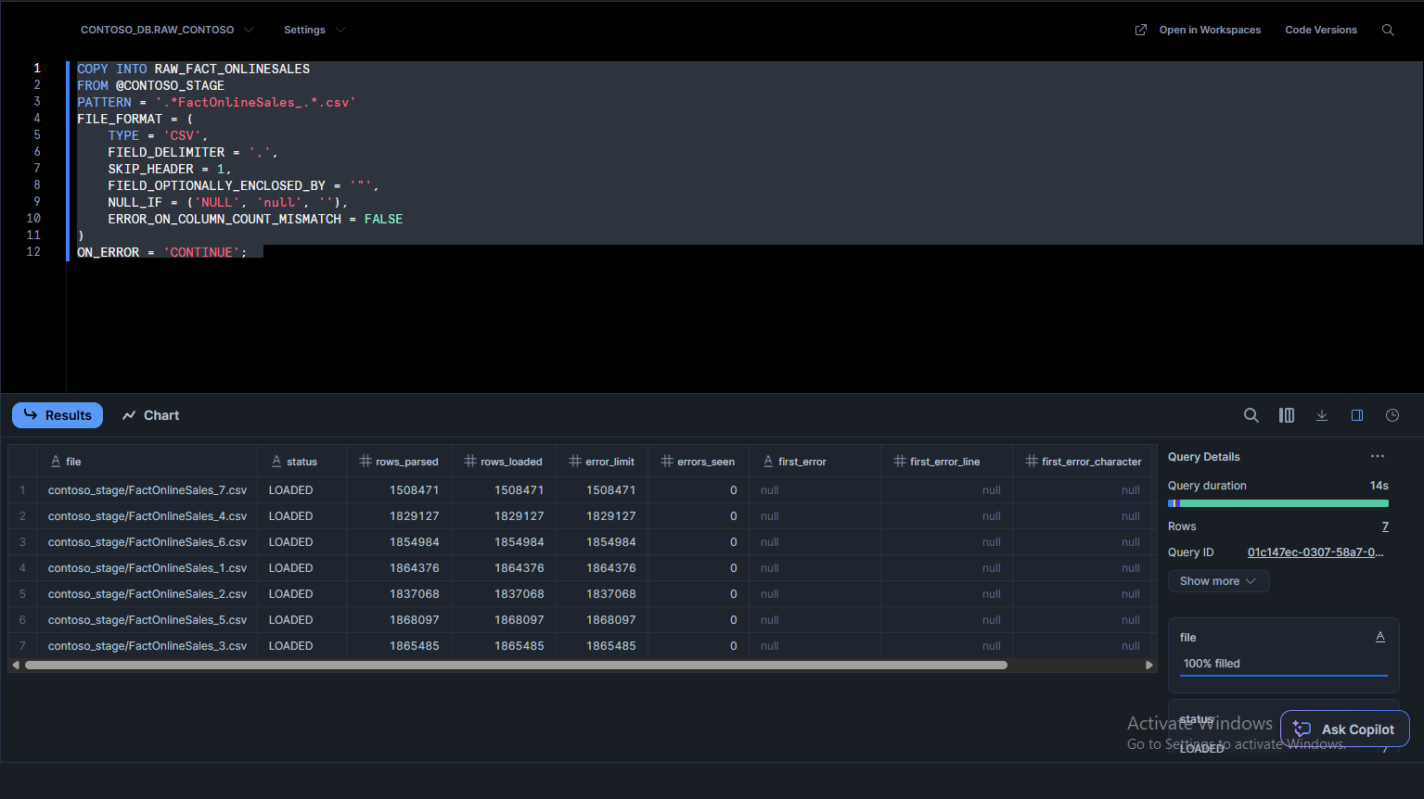

***Figure 5,6: ELT Ingestion script loading millions of rows into FactOnlineSales.***

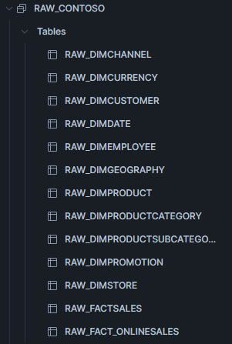

***Figure 7: Overview of Tables in RAW_CONTOSO***

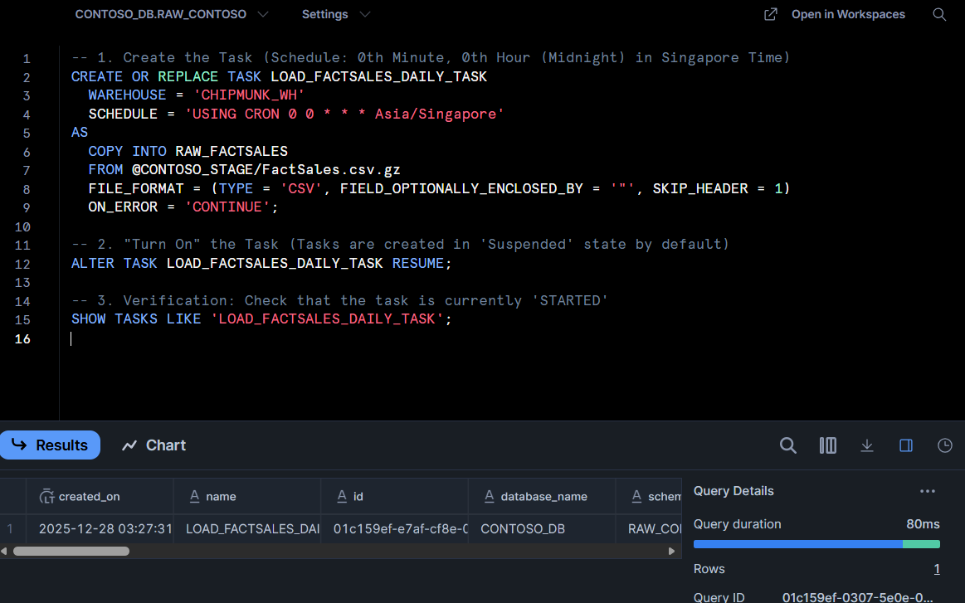

***Figure 8: Task to Automate snowflake tasks***

* **Ingestion:** We bulk-loaded millions of transaction rows into the FactSales and FactOnlineSales tables, along with 9 key Dimension tables (Product, Store, Geography, etc.) using COPY INTO commands. We verified the successful migration by running SELECT COUNT(*) benchmarks to confirm row counts matched the source system exactly.
* **Automation (Snowflake Tasks):** Moving beyond manual loading, we implemented **Snowflake Tasks** to monitor the internal stage and automatically ingest new files upon arrival. This ensures the warehouse stays current without manual intervention.

## **2.5.3 Data Warehouse Architecture (The Trusted Layer)**

To translate raw data into actionable business value, we architected a **Star Schema** optimized for Power BI DirectQuery.

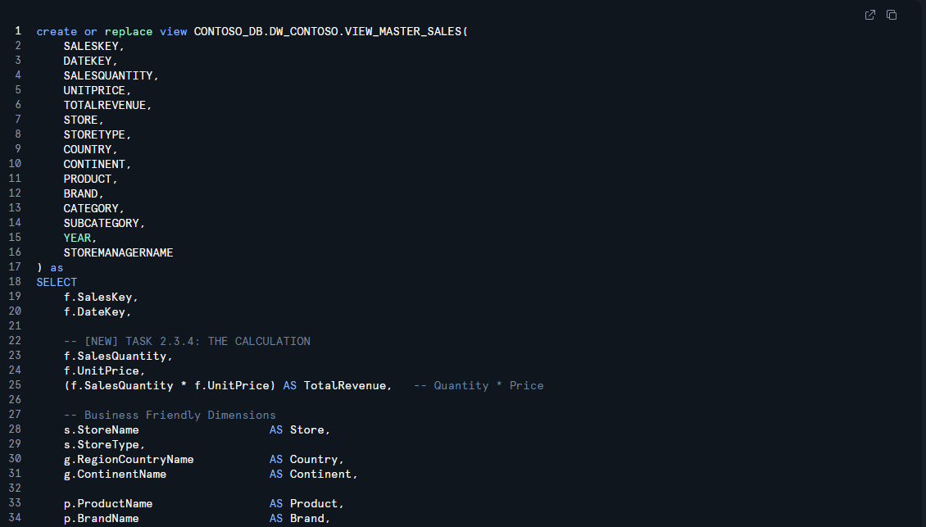

***Figure 9: Creation of VIEW_MASTER_SALES***

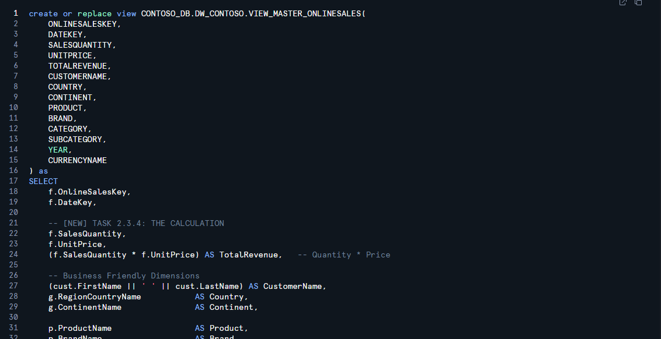

***Figure 10: Creation of VIEW_MASTER_ONLINESALES***

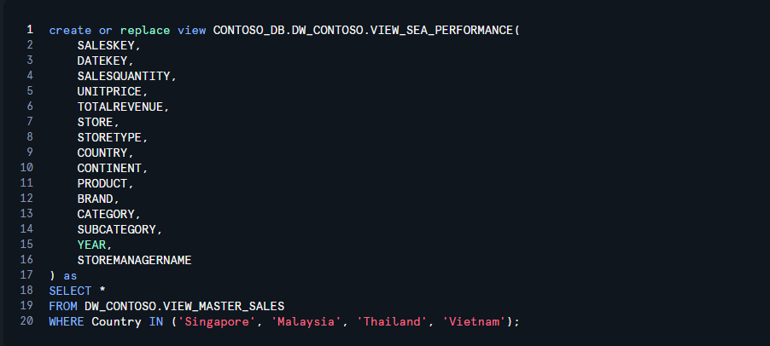

***Figure 11: Creation of VIEW_SEA_PERFORMANCE***

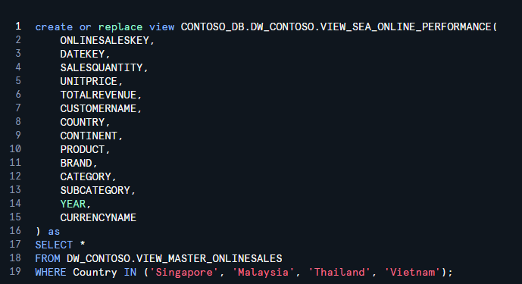

***Figure 12: Creation of VIEW_SEA_ONLINE_PERFORMANCE***

* **The Master View Strategy:** Instead of exposing raw tables directly to the BI tool, we created a consolidated logic layer starting with VIEW_MASTER_SALES. This view performs complex LEFT JOINS between the Fact tables and the 9 Dimensions, standardizing column names (e.g., renaming DimProductCategory_CategoryName to Category) and calculating derived metrics like TotalRevenue upstream.
* **Regional Partitioning (SEA View):** To satisfy the assignment’s specific requirement for South East Asia analysis, we engineered a specialized partition view, VIEW_SEA_PERFORMANCE. This view filters the global dataset using specific Country Keys for Singapore, Malaysia, Thailand, and Vietnam, ensuring regional managers only access relevant data.
* **Grain Integrity:** We executed rigorous "Grain Integrity Tests" to ensure that our joins did not inflate row counts. We reconciled revenue sums before and after the joins to confirm that the architecture introduced no data duplication errors.

## **2.5.4 Channel-Specific Reporting Views**

To support Contoso's omni-channel reporting requirements, we architected two distinct reporting views within the final Trusted OLAP Layer: **VIEW_RPT_SALES_MASTER** and **VIEW_RPT_ONLINE_SALES**. We deliberately separated these views for three strategic reasons:

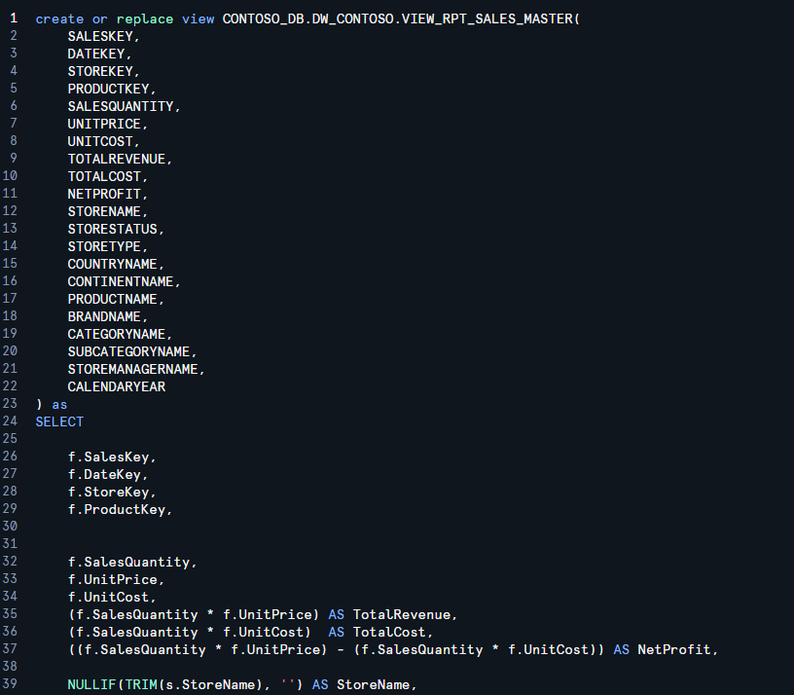

***Figure 13: Creation of VIEW_RPT_SALES_MASTER***

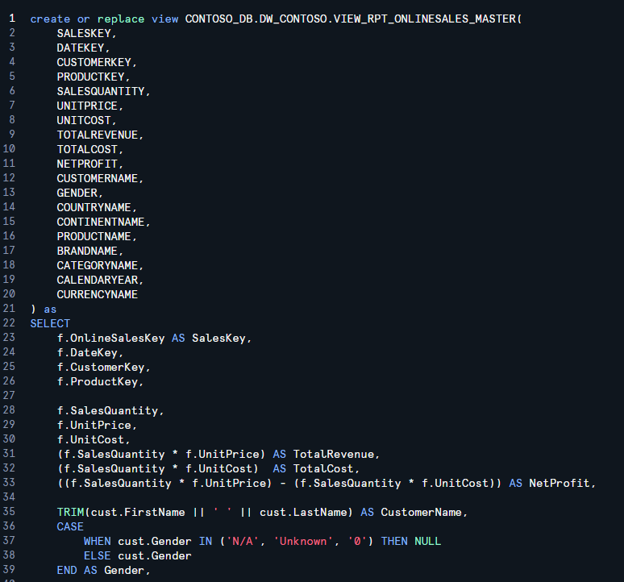

***Figure 14: Creation of VIEW_RPT_ONLINESALES_MASTER***

1. **Dimensional Relevance:** Physical store transactions depend heavily on DimStore and DimGeography, whereas online transactions rely on DimCustomer and shipping data. Separation ensured that dashboard developers were not presented with irrelevant columns.
2. **Granularity Control:** The VIEW_RPT_ONLINE_SALES view required specific logic to handle currency conversion and shipping dates that did not apply to physical point-of-sale transactions. Isolating this logic prevented grain mismatches.
3. **Performance Optimization:** By pre-filtering these datasets at the database level, we ensured that Regional Sales Managers could query physical store performance via DirectQuery without scanning millions of e-commerce rows, significantly reducing query latency.

## 2.5.5 Data Warehouse Naming & Structure Standards

To ensure data lineage traceability and ease of use for downstream dashboard developers, we enforced a strict naming convention and structural hierarchy across the Snowflake environment. We divided our data objects into three distinct logical layers:

**1. The Ingestion Layer (RAW_FACT_ / RAW_DIM_)**

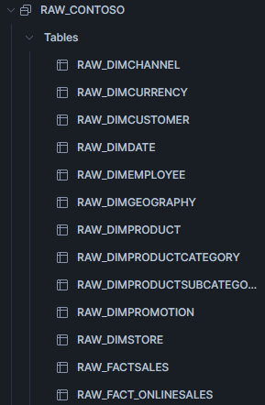

* **Object Type:** Physical Tables.
* **Naming Standard:** All tables loaded directly from the source were prefixed with RAW_ followed by the table type (FACT for transactions, DIM for dimensions).
  + *Examples:* RAW_FACT_SALES, RAW_DIM_PRODUCT, RAW_DIM_STORE.
* **Purpose:** These tables act as an exact 1:1 replica of the source CSV files. No transformations or renaming occurred here, ensuring we always had a pristine backup of the original data to revert to if transformations failed.

**2. The Integration Layer (VIEW_MASTER_)**

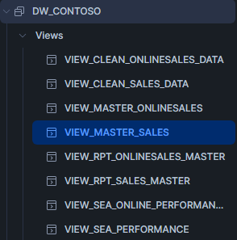

* **Object Type:** Virtual Views.
* **Naming Standard:** Views that combined multiple tables were prefixed with VIEW_MASTER_.
  + *Examples:* VIEW_MASTER_SALES (Joins FactSales + DimStore + DimDate).
* **Purpose:** This layer acted as the "Logic Engine." We used these views to:
  + Perform LEFT JOINS to denormalize the Star Schema.
  + Rename technical source columns (e.g., DimProductSubcategory_Name) into user-friendly business terms (e.g., SubCategory).
  + Handle NULL handling and casting logic.

**3. The Presentation Layer (VIEW_RPT_)**

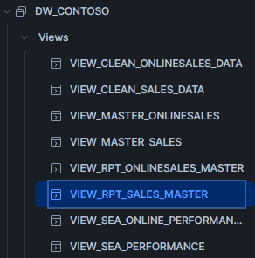

* **Object Type:** Secured/Optimized Views.
* **Naming Standard:** The final objects exposed to Power BI were prefixed with VIEW_RPT_ (Reporting).
  + *Examples:* VIEW_RPT_SALES (Physical Retail), VIEW_RPT_ONLINE_SALES (E-Commerce).
* **Purpose:** This layer served as the "API" for Power BI DirectQuery.
  + **Abstraction:** It decoupled the dashboard from the underlying logic. If we needed to change a calculation in VIEW_MASTER, we could do so without breaking the VIEW_RPT connection in Power BI.
  + **Security & Filtering:** Specific WHERE clauses (e.g., filtering for SEA markets or removing internal test records) were applied here to ensure end-users only saw "Clean" and "Approved" data.

## 2.5.6 Consolidation of ELT scripts

To ensure the project is fully reproducible by assessors, the team has consolidated all Sprint 1, 2, and 3 logic into a single **"Finalised Documented SQL Scripts"** pack hosted in GitHub.

**Execution Order Standard:** The scripts utilize a strict numeric prefix system (00_ to 06_) to enforce the correct dependency order. This prevents errors where a View is created before the underlying Table exists.

**The Standardized Sequence:**

* 00_db_and_schemas.sql: Idempotent setup of the Database and Schema objects.
* 01_file_formats_and_stage.sql: Configuration of external stages (S3/Azure) and file parsers.
* 02_load_dimensions.sql: Ingestion logic for all Dimension tables.
* 03_load_facts.sql: Ingestion logic for Transactional Fact tables.
* 04_create_master_views.sql: The transformation layer (User Story 3 - Cleaning & Logic).
* 05_final_reporting_views.sql: The trusted reporting layer for Power BI (User Story 3.4).
* 06_data_quality_and_validation.sql: Verification scripts proving row counts and integrity.

**Traceability:** A dedicated TRACEABILITY.md file has been included in the root directory to map each SQL file back to its specific User Story cards on the Trello board.

## **2.5.7 Bonus Tool Used: Snowflake CLI**

Snowflake CLI was used to also do this part as an additional attempt by Team Member Ho Wei Xian to help the group get the bonus points for having an additional tool for data query and management. Notably he was able to show that the **Snowflake CLI can upload files above the 250mb size limit without the need to split the files**, proving the utility of having the team switch to this approach if it were a real-world data engineering project that went beyond our assignment’s scope. (Also refer to section 2.6 for further information of how this tool was used to help build CI/CD.)

**Screenshot from Task 3.5.3: Snowflake CLI used to verify using LIST @‌contoso_stage that the files were loaded successfully:**

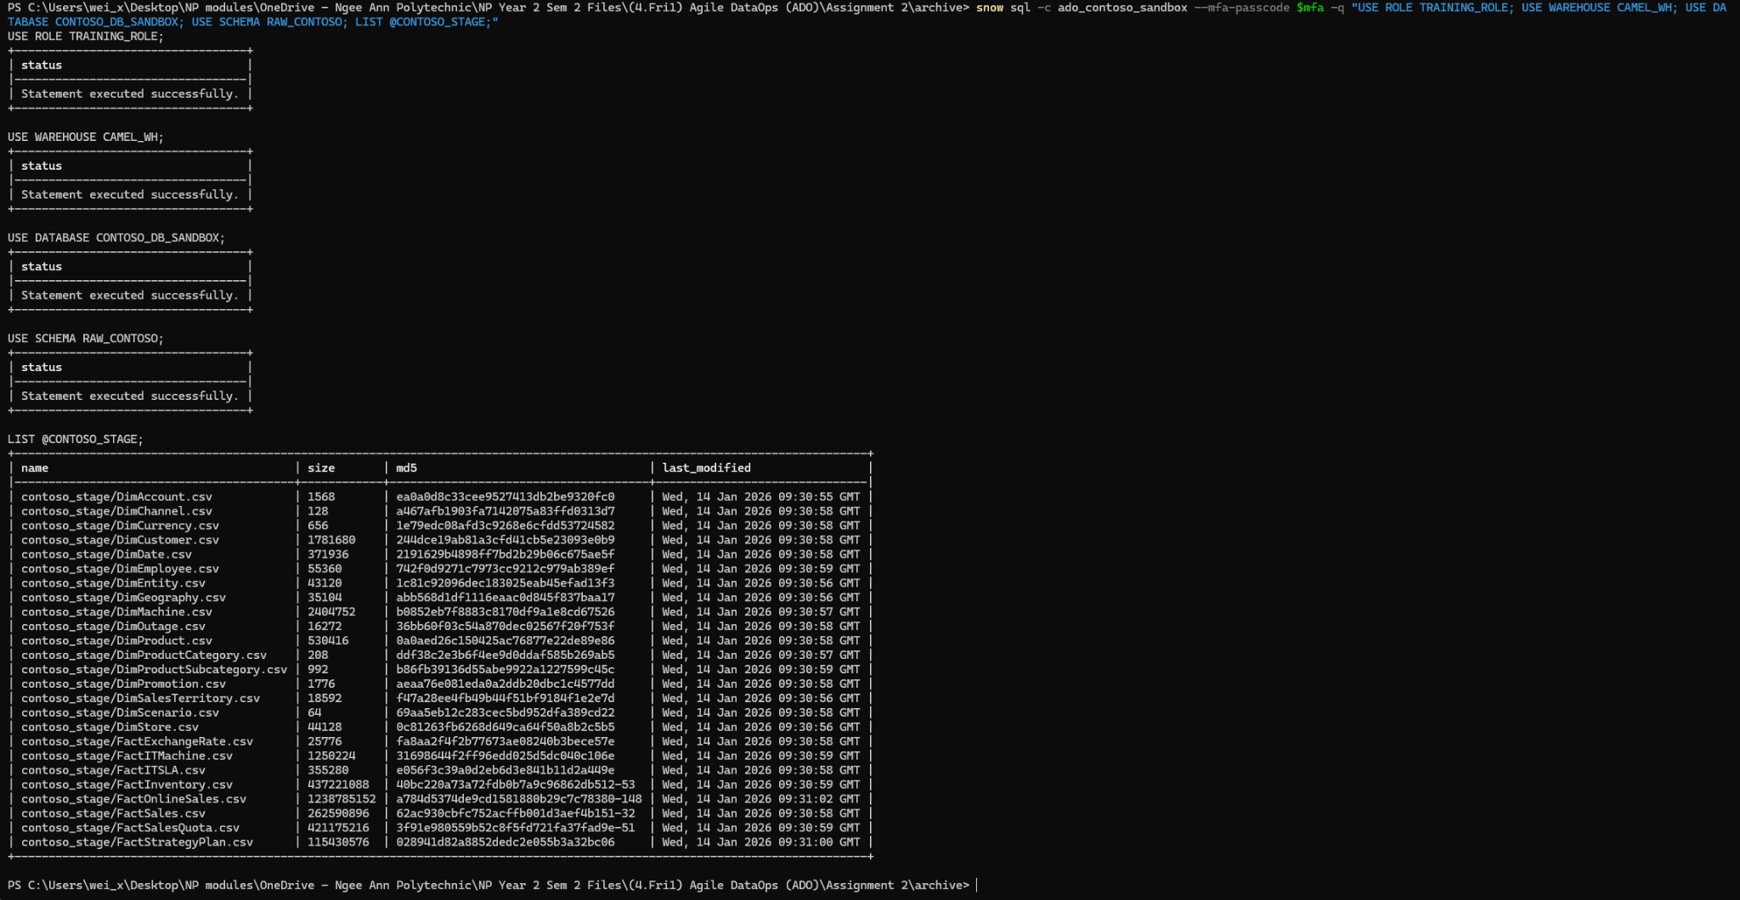

# 2.6 CI/CD and Version Control

Our CI/CD (Continuous Integration and Continuous Deployment) method uses GitHub as the single source of truth for the Contoso SQL pipeline and documentation, with controlled deployment into Snowflake (CAMEL account, Group 3).

**Version control approach (GitHub)**

All Snowflake build and load scripts were version controlled in GitHub to ensure every change had a traceable history and could be reviewed or rolled back if needed.

The key deliverable supporting this was the “Finalised Documented SQL Scripts (Sprint 3 runnable pack)” folder created under Task 3.5.2, which consolidated our production-ready SQL into a clearly ordered, runnable set of scripts:

* 00_db_and_schemas.sql
* 01_file_formats_and_stage.sql
* 02_load_dimensions.sql
* 03_load_facts.sql
* 04_create_master_views.sql
* 05_final_reporting_views.sql
* 06_data_quality_and_validation.sql
* README.md (run order and how to execute)
* TRACEABILITY.md (mapping and traceability)
* run_all_snowsql.sql (batch run helper)

This structure made the repository readable and audit friendly. A reviewer can immediately understand the run sequence, what each script does, and where evidence queries are located. It also supports team collaboration because work can be split by script area (setup, formats and stage, loads, views, validation) without mixing unrelated changes.

**Continuous Integration (CI)**

All development changes are made in GitHub (or locally) and merged into the main branch via Pull Requests (PRs, pull requests).

The recommended day-to-day CI workflow is:

1. Team members create short-lived feature or fix branches.
2. They commit small changes with clear messages.
3. They open a PR into main.
4. Another teammate reviews and approves before merge.
5. After merging, branches are deleted to keep the repository clean.

Continuous Deployment (CD)

Deployments always execute SQL from the main branch into Snowflake in a controlled promotion flow:

* SANDBOX first: CONTOSO_DB_SANDBOX
* MAIN only if approved by the team: CONTOSO_DB

Snowflake Git integration is read-only. Snowflake cannot push commits back to GitHub, so all edits happen in GitHub and Snowflake pulls updates using FETCH.

Deployment steps in Snowflake follow a consistent pattern:

1. ALTER GIT REPOSITORY ... FETCH to sync latest commits
2. LS to confirm required SQL scripts exist in the repo path
3. Set session context (USE ROLE, USE WAREHOUSE, USE DATABASE, USE SCHEMA)
4. Run scripts using EXECUTE IMMEDIATE FROM @<repo_path> (this runs in the current session context)

A key concept is that EXECUTE IMMEDIATE FROM ... runs in the current session context (USE DATABASE, USE SCHEMA), not “inside” the admin database/schema where the repository object is stored.

**Roles and access model**

**GitHub**

Team members have admin-level access through an organization team for repo governance and GitHub Actions configuration.

**Snowflake**

Responsibilities are separated to reduce risk:

* ACCOUNTADMIN is used only for one-time integration setup (SECRET, API INTEGRATION, GIT REPOSITORY, and optional auto-fetch task).
* CONTOSO_G3_ROLE is the standard execution role for teammates to list repo files and deploy into SANDBOX (and MAIN only if agreed).

Integration objects are stored in:

* Database and schema: CONTOSO_G3_CICD_TEST_ADMIN.GIT_INTEGRATIONS
* Git repository object: CONTOSO_G3_REPO

**Repository pipeline structure**

SQL deployment is organised into a predictable, ordered pipeline under SQL/pipeline/, typically executed in sequence:

* 00_db_and_schemas.sql through 06_data_quality_and_validation.sql

This ensures setup, ingestion, transformations, reporting views, and validation are reproducible.

**Deployment automation using GitHub Actions**

We implemented deployment automation using GitHub Actions with a workflow (deploy-and-validate) that runs the same Sprint 3 runnable pack in a fixed order to create or refresh the sandbox environment.

Under Task 3.7.2, the workflow was configured so that new code changes can trigger an automated deployment when merged (for example, merging into the main branch).

**Screenshot of aforementioned YAML workflow:**  
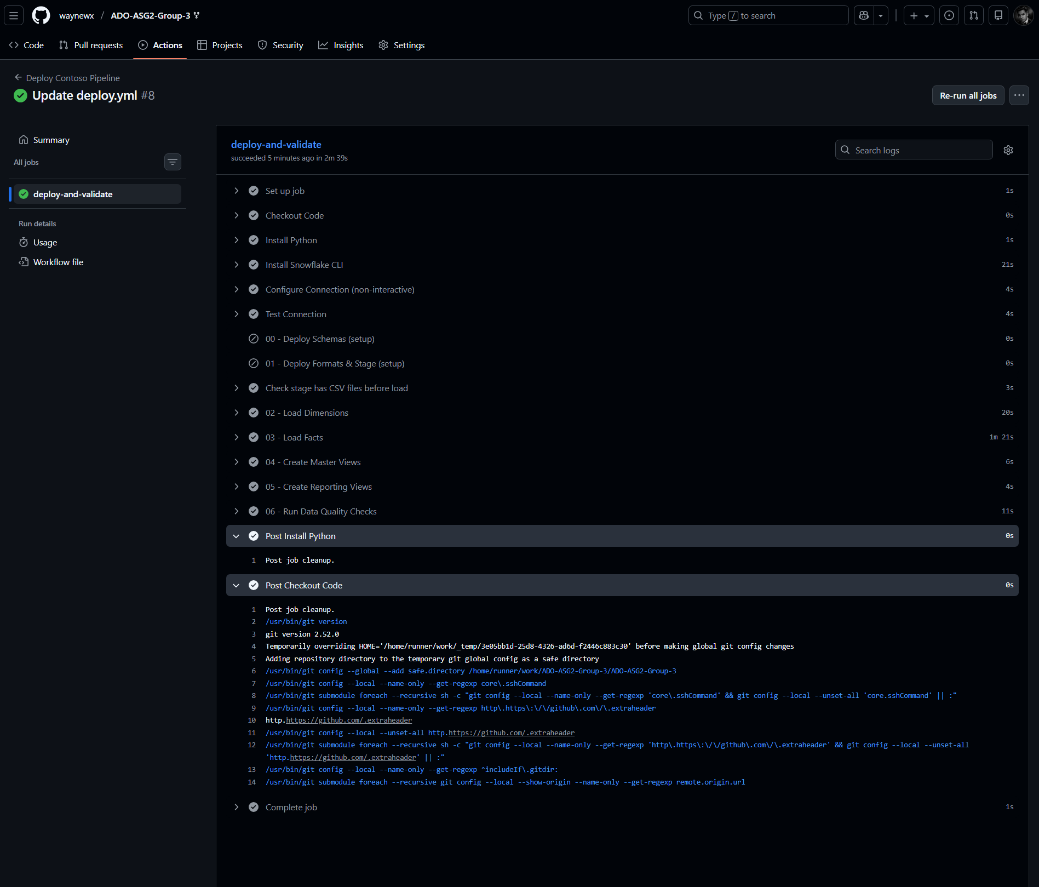

**Screenshot of aforementioned SANDBOX:** 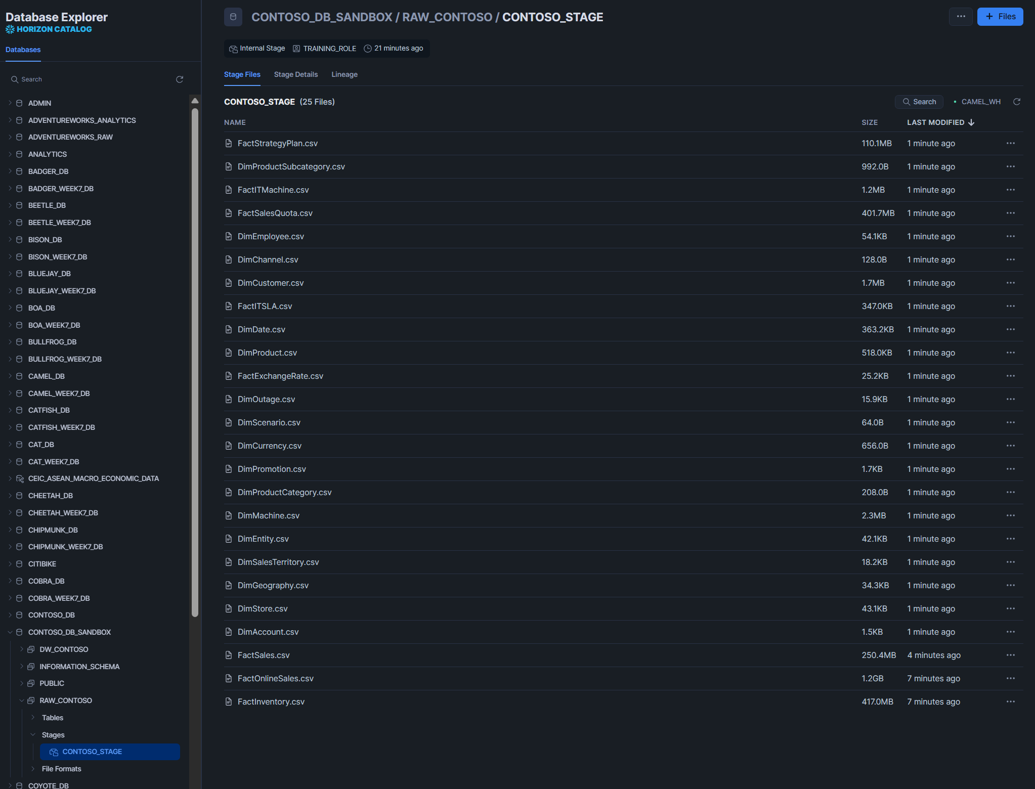

At a high level, the deployment workflow performs these actions:

1. Checkout repository code
2. Install required tooling  
   * Installs Python (Python programming language) as part of the runner setup
   * Installs Snowflake CLI (Command Line Interface) for non-interactive execution
3. Configure Snowflake connection (non-interactive)  
   * Uses repository secrets for authentication (credentials are not hard coded into scripts)
4. Test connection

1. Deploy and validate in sequence  
   * Deploy schemas and setup (00)
   * Deploy formats and stage (01)
   * Check stage has required CSV files before load
   * Load dimensions (02)
   * Load facts (03)
   * Create master views (04)
   * Create reporting views (05)
   * Run data quality checks (06)

This ensures deployments are repeatable and consistent. Instead of manual copy paste into Snowsight worksheets, the same validated sequence runs every time, reducing human error and making results easier to reproduce during grading or demonstrations.

**Execution evidence captured (validation proof)**

Under Task 3.5.3, execution evidence was captured by running the runnable pack against a sandbox database environment and taking screenshots of successful object creation and data previews.

Evidence includes:

* Sandbox database and schemas created (for example, CONTOSO_DB_SANDBOX with RAW_CONTOSO and DW_CONTOSO)
* Views created and populated (for example reporting views like VIEW_RPT_ONLINESALES_MASTER)
* Data preview screenshots confirming the pipeline produced usable outputs
* Evidence queries from the validation script (06_data_quality_and_validation.sql) executed to demonstrate checks and correctness

This connects the version controlled scripts to real execution results, showing that the repo is not only documentation, but also runnable and verified.

**Aforementioned proof of the script working on the sandbox DB to populate values:**  
 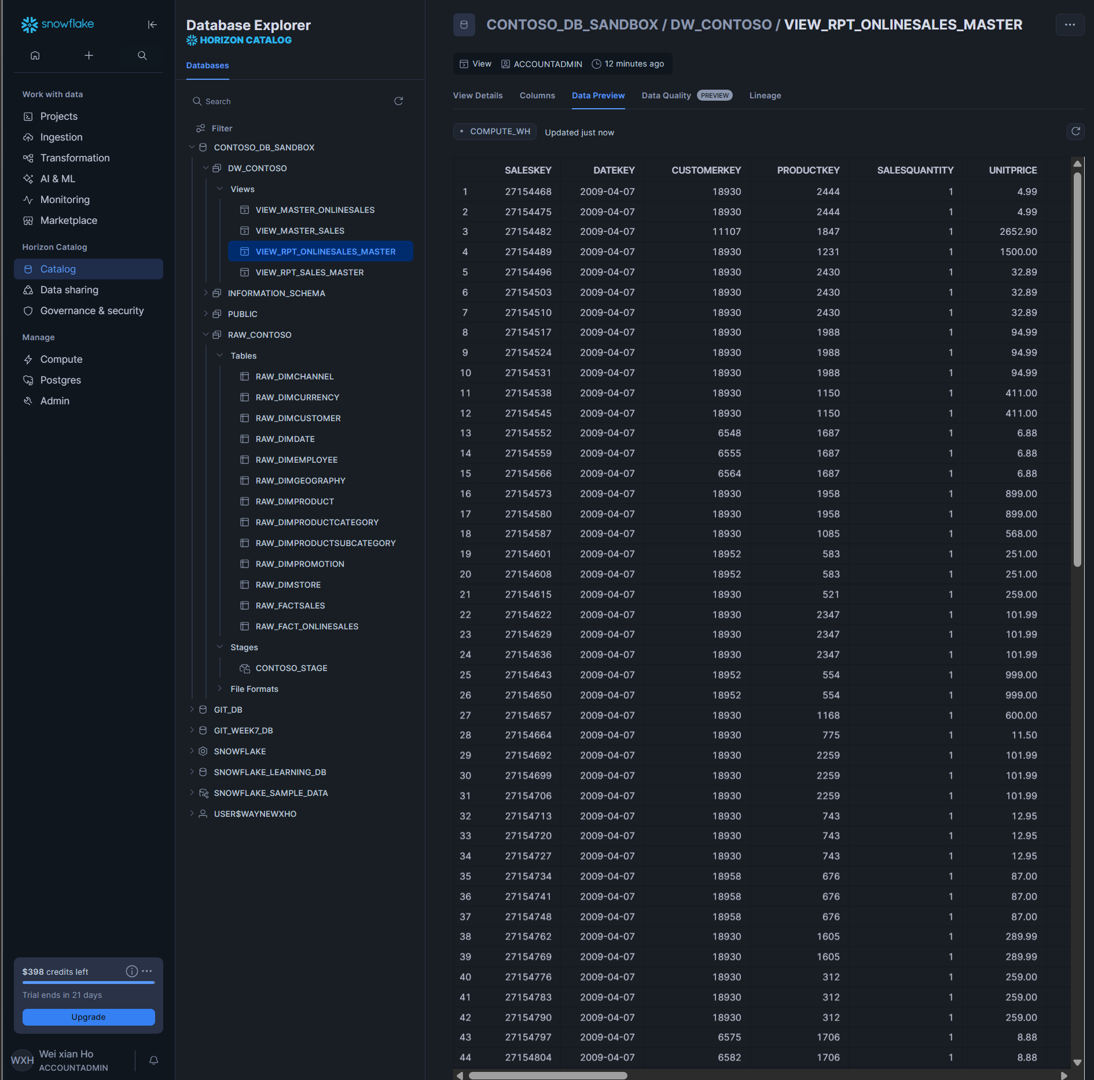

**Optional automation and maintenance: Snowflake Git repository auto-fetch**

In addition to GitHub Actions, we also set up an automatic fetch mechanism inside Snowflake using Snowflake Git integration.

A Git Repository object (CONTOSO_G3_REPO) was created in a dedicated admin database and schema (CONTOSO_G3_CICD_TEST_ADMIN.GIT_INTEGRATIONS). A stored procedure (sp_fetch_contoso_g3_repo) plus a scheduled task (task_fetch_contoso_g3_repo) was used to fetch updates periodically (for example, every 10 minutes).

This does not auto-deploy by itself, but it ensures Snowflake can stay synced with the latest repository state for review or controlled execution.

**Screenshot of code for automatic 10-minute interval fetching:**  
 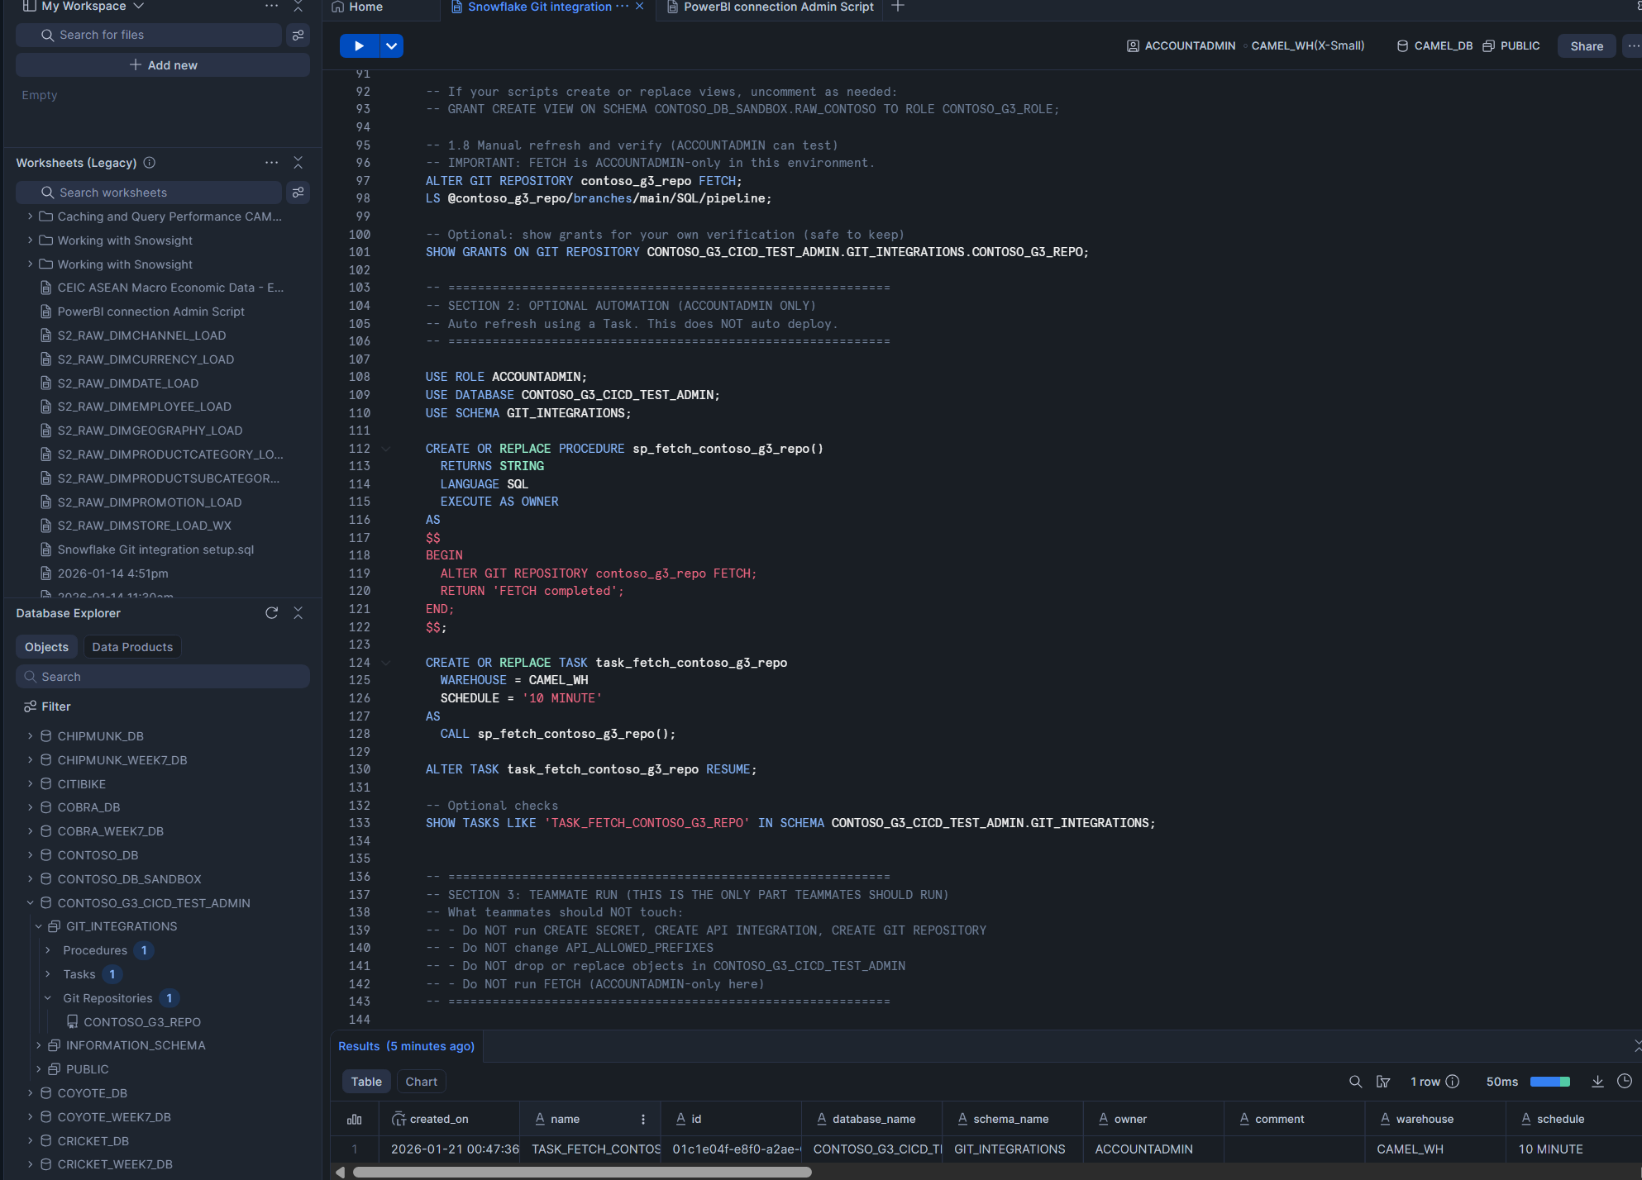

**Troubleshooting (common issues)**

Troubleshooting is straightforward:

* “File not found” typically means a missing FETCH
* “Location not allowed” typically means the API allowed prefix does not match the repo origin
* Permission errors indicate missing grants to CONTOSO_G3_ROLE

**Evidence of Following CI/CD protocol:**

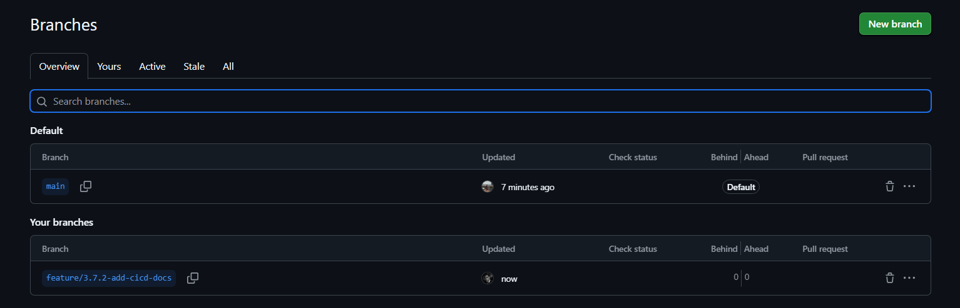

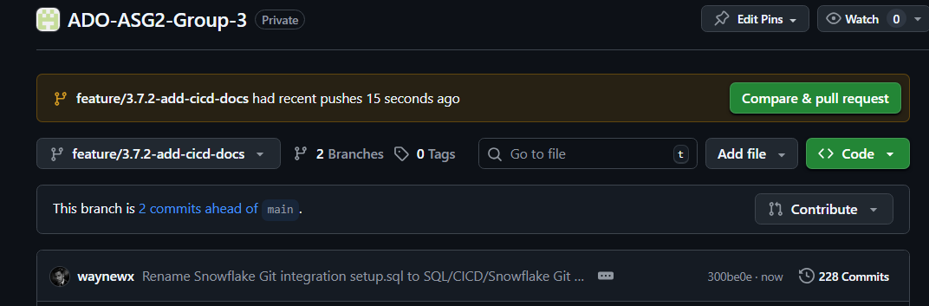

**Evidence of Pull Request Made:**

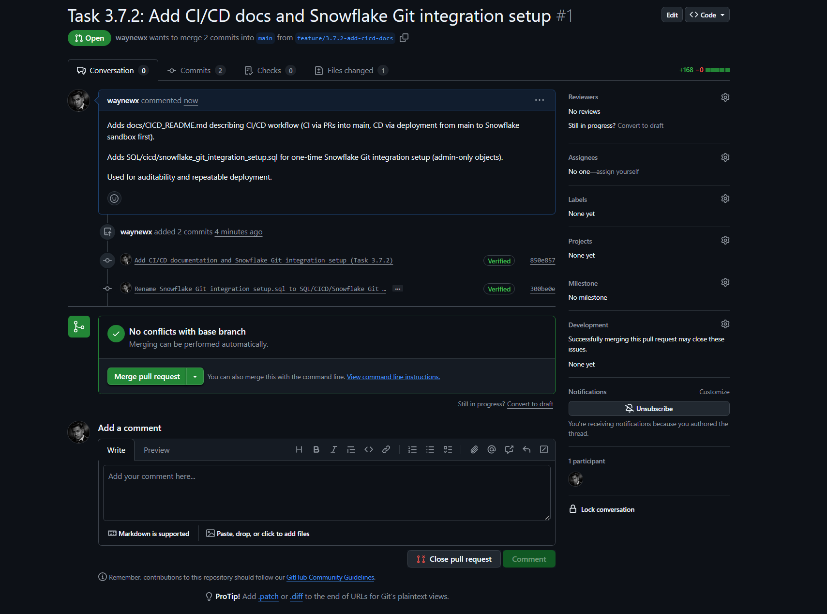

**Evidence of a Pull Request Merged and Closed:**

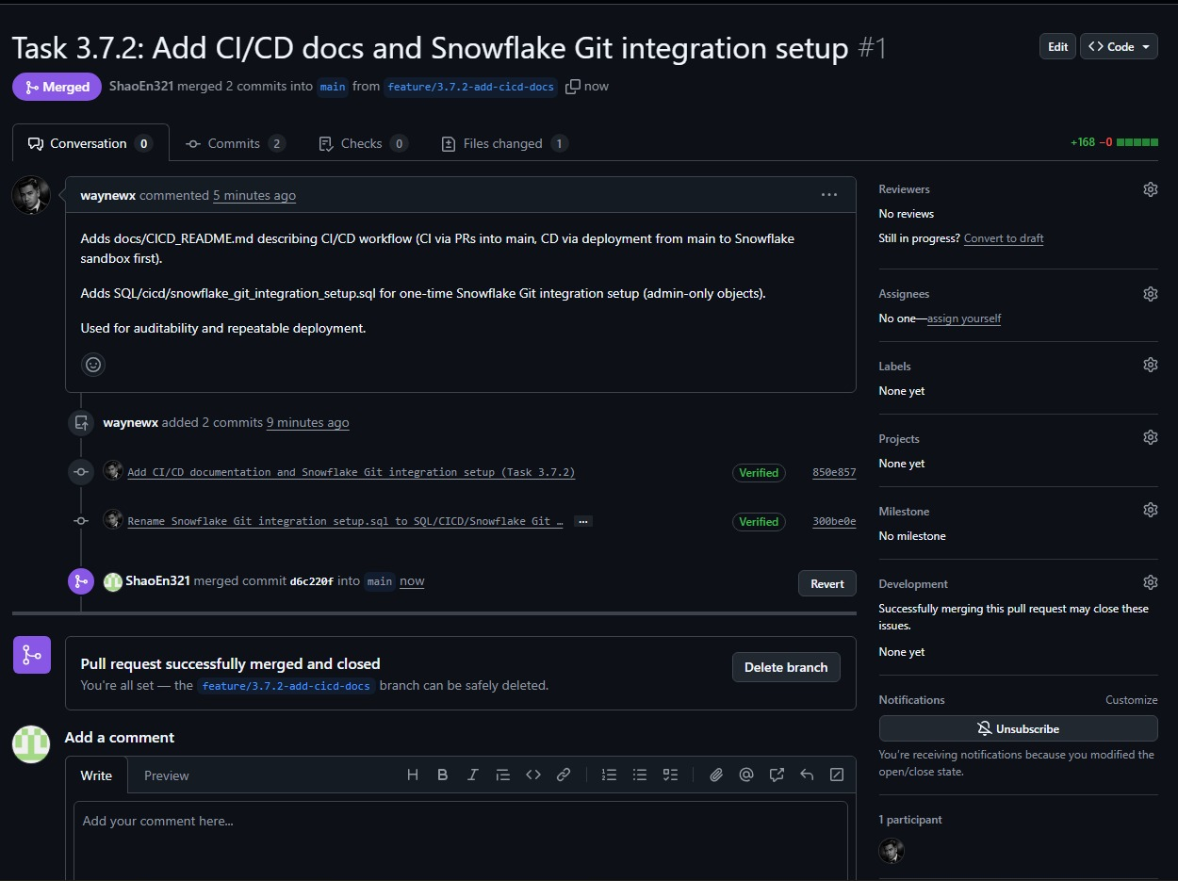  
  
 **Branch deleted safely:   
**

**End of Process.**

# 2.7: Dashboard Insights

## 2.7.1 Dashboard Overview

The **Contoso Strategic Performance Suite** is a centralized Power BI business intelligence platform designed to transform raw transaction data into actionable insights across the organization’s financial, operational, and product verticals. Built upon a rigorous data engineering foundation that ensures entity resolution and reporting accuracy, this solution addresses the fragmented decision-making needs of key stakeholders. It replaces static reporting with a multiple dashboard environment that serves as the organization's "Single Source of Truth."

**For Product Owner(Shao En)**

The objective of this analysis was to evaluate sales volume and profitability across the Contoso product portfolio to identify opportunities for inventory optimization for the Product Owner

**This Dashboard shows analysis for 2007. (filtered using the slicer)**

Dashboard Component Analysis:   
1. Key Performance Indicators (KPIs)

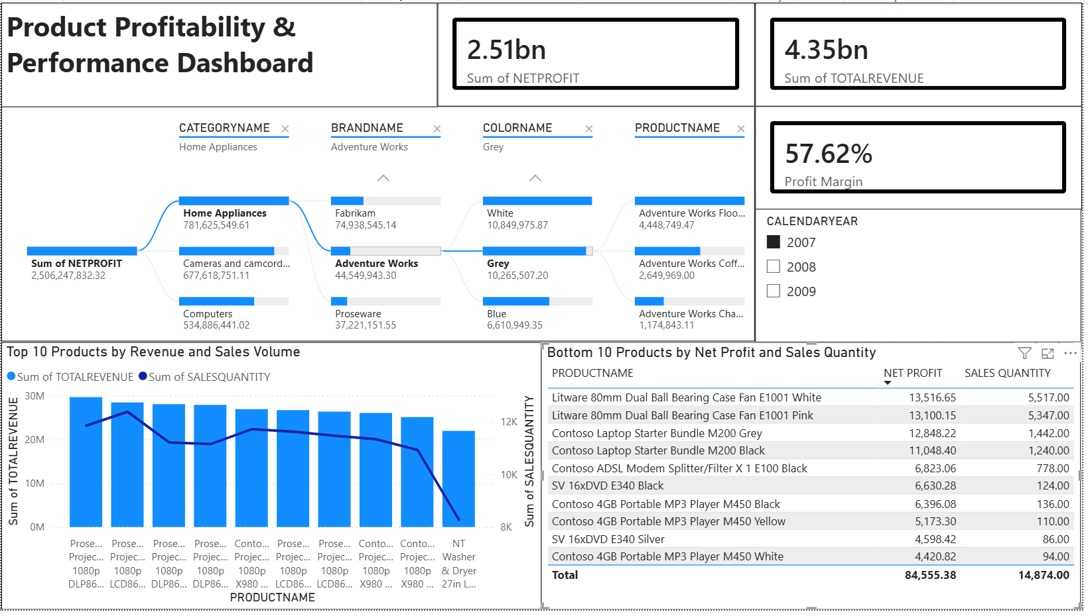

The executive scoreboard at the top of the dashboard provides an immediate snapshot of the portfolio's financial performance.

**Card 1: Sum of NET PROFIT**

* **Current Value:** **$2.51bn**
* **Definition:** This figure represents the absolute earnings of the organization after all costs (COGS, operational expenses) have been deducted from the Total Revenue.
* **Significance for Product Manager:** This is the "North Star" metric. While Revenue shows how much product we moved, Net Profit tells us if the business is actually sustainable. A high revenue with low profit would indicate an issue with pricing or high inventory costs, but the strong $2.51bn figure confirms healthy operational efficiency.

**Card 2: Sum of TOTAL REVENUE**

* **Current Value:** **$4.35bn**
* **Definition:** The gross income generated from all sales transactions before any expenses are subtracted. It acts as the "Top Line" growth indicator.
* **Significance for Product Manager:** This measures market demand and market share. It answers the question: *"Are customers buying our products?"* Comparing this against Net Profit helps identify if our high-volume sellers (like the Projectors) are pricing correctly.

**Card 3: PROFIT MARGIN %**

* **Current Value:** **57.62%**
* **Definition:** A calculated measure derived from Net Profit / Total Revenue. It indicates the percentage of every dollar earned that the company keeps as profit.
* **Significance for Product Manager:** This is the primary measure of **Product Efficiency**. A 57.62% margin is exceptionally high for hardware retail (where 20-30% is standard).
  + **Insight:** This high percentage proves that our strategy of focusing on premium "Home Appliances" and high-end "Projectors" is working. We are not just selling *more* (Volume); we are selling *smart* (Value). It validates the decision to discontinue low-margin items like the MP3 players to protect this efficiency score.

2. The "Root Cause" Analyzer (Decomposition Tree)

* **Visual Type:** AI Decomposition Tree
* **Metric Analyzed:** Sum of NETPROFIT
* **Breakdown Dimensions:** Category $\rightarrow$ Brand $\rightarrow$ Color $\rightarrow$ Product
* **Strategic Purpose:**This is the dashboard's primary exploratory tool. Unlike standard static charts, this AI-driven visual enables the Product Manager to perform "Ad-Hoc Root Cause Analysis." It answers the question *“Where exactly is our profit coming from?”* by dynamically splitting the data at each level of the hierarchy.
* **Key Insight from Dashboard:**As visible in the active path, the tree identifies **Home Appliances** as the dominant category with **$781M** in profit. By drilling down, we reveal a critical insight for the supply chain team: the **Fabrikam** brand is the top performer within this category, and specifically, their **"White"** colored appliances are driving the highest returns. This suggests that customers prefer neutral aesthetics for appliances, guiding future design decisions.

3. Top 10 Leaders: Volume vs. Value (Combo Chart)

* **Visual Type:** Line and Clustered Column Chart
* **X-Axis:** Product Name
* **Y-Axis (Bars):** Sum of TOTAL REVENUE (Financial Value)
* **Y-Axis (Line):** Sum of SALES QUANTITY (Unit Volume)
* **Strategic Purpose:**This visual performs a **Correlation Analysis** between financial success (Bars) and operational demand (Line).
  + **Why it matters:** A Product Manager needs to know if a product is a "Cash Cow" (High Revenue, High Volume) or a "Premium Niche" (High Revenue, Low Volume).
* **Key Insight from Dashboard:**The **Proseware Projector 1080p** series occupies the top three spots, showing massive revenue bars supported by a high-volume trend line. This correlation confirms that these are our "Star Products"—they are expensive *and* popular. Managing inventory for these is critical; a stockout here would be catastrophic for the bottom line.

4. The "Kill List": Bottom 10 Products (Table)

* **Visual Type:** Data Table (Sorted Ascending by Profit)
* **Columns:** Product Name, Sum of NET PROFIT, Sum of SALES QUANTITY
* **Strategic Purpose:**This visual directly addresses the User Story requirement to *"identify unpopular items for discontinuation."* By filtering for the "Bottom 10," it isolates the portfolio's "dead weight"—products that consume warehouse space and capital but generate negligible returns.
* **Key Insight from Dashboard:**The table exposes the **Contoso 4GB Portable MP3 Player** series (White, Yellow, Black) as the worst performers. These items are generating as little as **$4,420** in total profit. Compared to the millions generated by the top performers, these legacy items are statistically insignificant and are prime candidates for an immediate "End-of-Life" (EOL) liquidation strategy.

5. Temporal Control (Date Slicer)

* **Visual Type:** Filter / Slicer
* **Field:** CALENDARYEAR (2007, 2008, 2009)
* **Strategic Purpose:**Provides **Temporal Context**.
  + **Why it matters:** Aggregate data can hide trends. This slicer empowers the user to answer time-sensitive questions like *“Did the recession in 2008 affect our Projector sales?”* or *“Are MP3 player sales declining year-over-year?”* It transforms the dashboard from a static snapshot into a dynamic historical analysis tool.

**For regional sales manager (Jerremmy)**

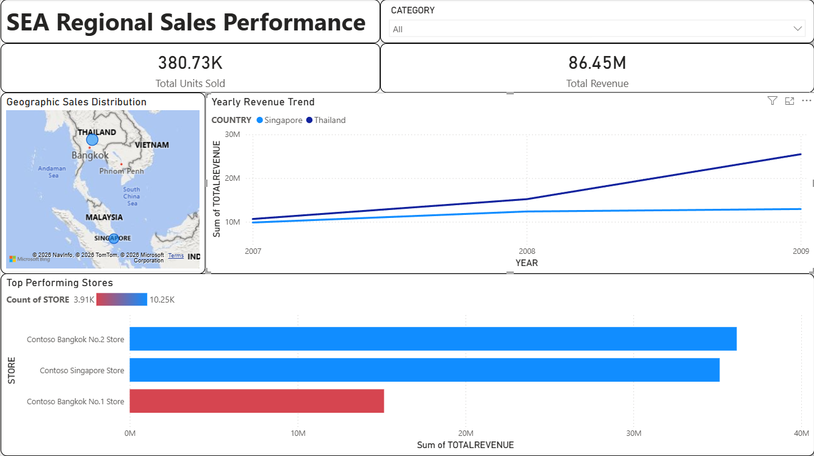

**Objective:** The objective of this analysis was to evaluate sales performance across the Southeast Asia (SEA) region to identify high-growth markets and pinpoint underperforming store locations for the Regional Sales Manager.

Dashboard Component Analysis:

1. Key Performance Indicators (KPIs)

The executive scoreboard at the top of the dashboard provides an immediate snapshot of the region's commercial health.

**Card 1: Sum of TOTAL REVENUE**

* **Current Value:** **$86.45M**
* **Definition:** The gross income generated from all sales transactions within the SEA region before any expenses are deducted.
* **Significance for Regional Manager:** This is the primary measure of market size and financial success. It answers the question: "How much money is this region contributing to the global company?" A figure of $86.45M confirms that SEA is a significant revenue driver.

**Card 2: Sum of SALES QUANTITY (Total Units Sold)**

* **Current Value:** **380.73K**
* **Definition:** The total physical quantity of items sold across all stores in the region.
* **Significance for Regional Manager:** This measures operational workload and demand. While Revenue tracks money, "Units Sold" tracks logistical pressure. A high volume (380K+) indicates high demand on the supply chain and warehouse operations in Singapore and Bangkok.

2. The "Geographic" Analyzer (Map Visual)

* **Visual Type:** Bubble Map
* **Metric Analyzed:** Sum of TOTAL REVENUE by Country
* **Strategic Purpose:** This is the dashboard’s primary spatial tool. It allows the Regional Manager to instantly visualize market concentration without reading tables. The size of the bubbles corresponds to revenue, providing an intuitive understanding of "Where is the money coming from?"
* **Key Insight from Dashboard:** The visual highlights **Thailand and Singapore** as the two dominant markets in the region. The large bubbles over Bangkok and Singapore City overshadow neighboring markets like Vietnam and Malaysia, suggesting that management should focus their primary marketing and logistics efforts on these two key hubs.

3. Regional Growth Trends (Line Chart)

* **Visual Type:** Multi-Line Chart
* **X-Axis:** Year (2007–2009)
* **Y-Axis:** Sum of TOTAL REVENUE
* **Strategic Purpose:** This visual performs a **Trend Analysis** to separate "Growth" from "Stagnation." A Regional Manager needs to know where to invest future capital—you don't invest in flat markets; you invest in growing ones.
* **Key Insight from Dashboard:** The chart reveals a clear divergence in performance. While Singapore (Light Blue) shows a relatively flat or slow-growth trend, **Thailand (Dark Blue)** is on a sharp upward trajectory from 2008 to 2009. This identifies Thailand as the region's "Star" growth engine, justifying increased investment in that country.

4. Store Performance Ranking (Bar Chart)

* **Visual Type:** Clustered Bar Chart with Conditional Formatting
* **Y-Axis:** Store Name
* **X-Axis:** Sum of TOTAL REVENUE
* **Strategic Purpose:** This visual serves as the "Exception Management" tool. By ranking stores side-by-side, it exposes variances in performance between locations that should theoretically be similar. The use of **Conditional Formatting** (Red/Blue) automates the identification of underperformance.
* **Key Insight from Dashboard:** The chart exposes a critical operational failure: **Contoso Bangkok No.1 Store** (Red Bar) is generating less than half the revenue of **Contoso Bangkok No.2 Store** (Blue Bar), despite being in the same city. This "Red Flag" immediately alerts the manager to investigate local issues—such as poor stock availability, bad management, or location issues—at the No.1 Store.

5. Category Control (Slicer)

* **Visual Type:** Dropdown Slicer
* **Field:** Product Category (Audio, Cameras, etc.)
* **Strategic Purpose:** Provides Granular Context.
* **Why it matters:** Regional performance can look good overall while specific categories are failing. This slicer empowers the user to perform "Ad-Hoc Analysis" (e.g., "Is the revenue growth in Thailand driven by Cameras or Home Appliances?"). It transforms the static report into an interactive exploration tool.

**For customer analyst (Simon)**

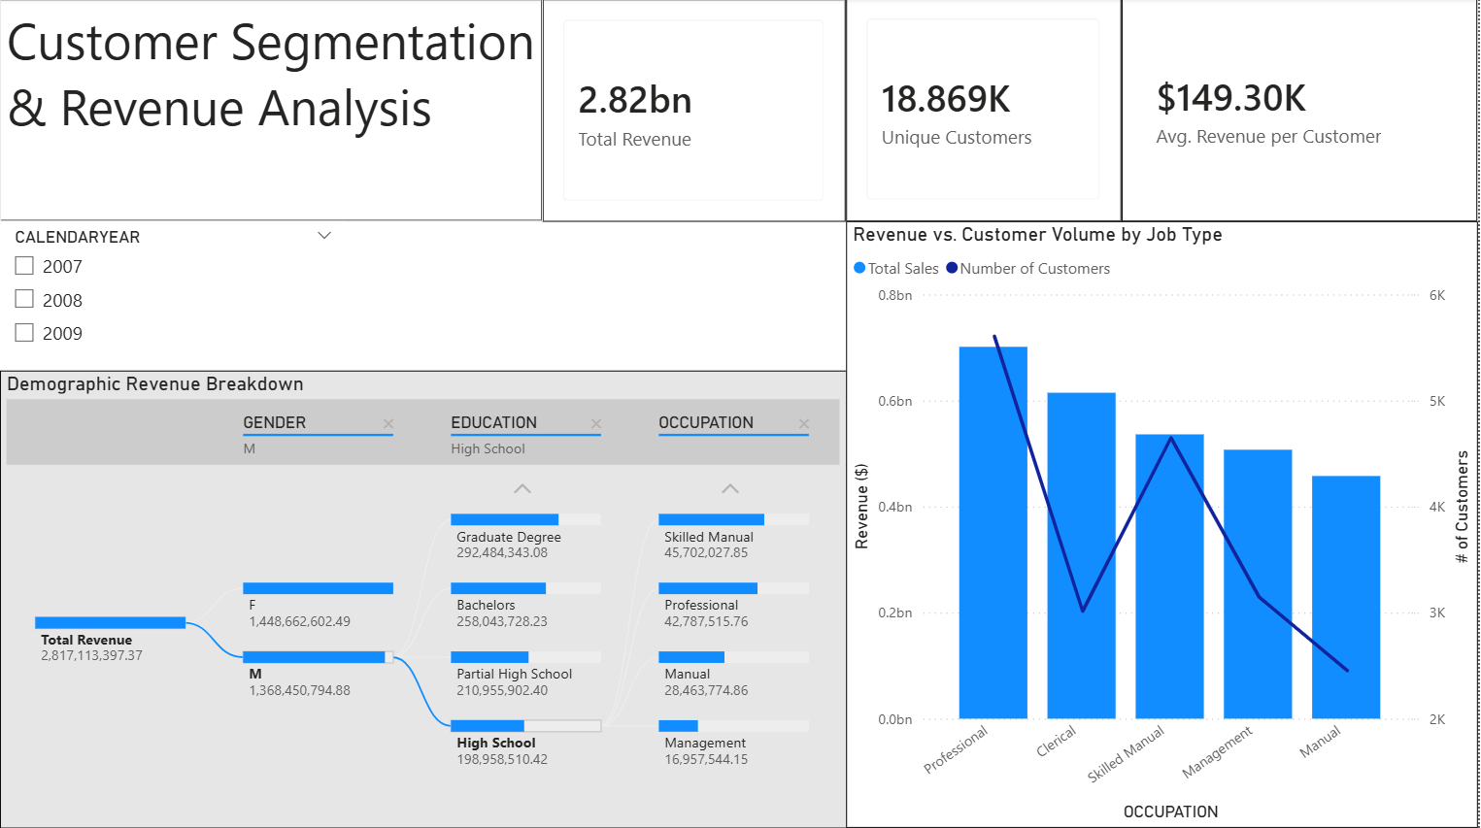

**Objective:** The objective of this analysis was to evaluate the Contoso customer base by Gender, Education, and Occupation to identify high-value customer personas and optimize advertising spend for the Marketing Manager.

**Dashboard Component Analysis:**

**1. Key Performance Indicators (KPIs)**

The executive scorecard at the top provides a high-level summary of the customer base's value and size.

* **Card 1: Total Revenue**
  + **Current Value:** $2.82bn
  + **Definition:** The total gross income generated from Online Sales during the selected period.
  + **Significance for Marketing Manager:** This measures the total market size. A figure of $2.82bn confirms that the Online channel is a massive revenue driver, justifying significant budget allocation for targeted campaigns.
* **Card 2: Unique Customers**
  + **Current Value:** 18.869K
  + **Definition:** The distinct count of individual customers who made at least one purchase.
  + **Significance for Marketing Manager:** This tracks "Market Reach." It tells the manager that our revenue is concentrated among ~19,000 individuals, helping to calculate the cost-per-acquisition (CPA) limits.
* **Card 3: Avg. Revenue per Customer**
  + **Current Value:** $149.30K
  + **Definition:** The average lifetime value (LTV) derived from a single customer (Total Revenue / Unique Customers).
  + **Significance for Marketing Manager:** This is the "Efficiency" metric. It sets the benchmark for customer quality. If a specific demographic segment (e.g., Students) falls significantly below $149k, they are a low-priority target. If a segment is above it, they are VIPs.

**2. Demographic Revenue Breakdown (Decomposition Tree)**

* **Visual Type:** Decomposition Tree (AI Visual)
* **Metric Analyzed:** Total Revenue breakdown by Gender, Education, and Occupation.
* **Strategic Purpose:** This is the dashboard’s "Discovery Engine." It allows the analyst to drill down into the data in any order to find hidden patterns (e.g., "Do Men with degrees spend more than Women without degrees?"). It replaces multiple static pie charts with one interactive tool.
* **Key Insight from Dashboard:** The visual reveals a surprising balance in gender, with Females ($1.45bn) slightly edging out Males ($1.37bn). However, the drill-down into the Male demographic uncovers a counter-intuitive insight: **"Partial College"** attendees ($408M) actually generate more revenue than "Bachelors" or "Graduate Degree" holders. This suggests that marketing messaging should not be exclusively "white-collar" or degree-focused.

**3. Revenue vs. Customer Volume by Job Type (Combo Chart)**

* **Visual Type:** Line and Clustered Column Chart
* **Y-Axis (Bars):** Total Revenue (Market Value)
* **Secondary Y-Axis (Line):** Number of Customers (Market Volume)
* **Strategic Purpose:** This visual performs a "Volume vs. Efficiency" analysis. By overlaying the *number* of people (Line) against the *money* they spend (Bars), the manager can identify segments that are profitable despite being small (High Efficiency) versus segments that are just "noise" (High Volume, Low Revenue).
* **Key Insight from Dashboard:**
  + **The "Cash Cow":** **Professionals** are the dominant leader in both volume (Line peak) and revenue (Tallest Bar), making them the safest target for broad ad campaigns.
  + **The "Hidden Gem":** **Clerical** workers show a sharp drop in customer count (the Line dips) but maintain the second-highest revenue bar. This indicates a **significantly higher Average Spend per Person** than the "Skilled Manual" or "Management" groups. The recommendation is to target Clerical workers with "High Ticket" item advertisements.

**4. Temporal Filter (Slicer)**

* **Visual Type:** Vertical List Slicer
* **Field:** Calendar Year (2007–2009)
* **Strategic Purpose:** Provides context and trend validation. Customer behavior shifts over time (e.g., during the 2008 financial crisis). This control allows the manager to isolate performance years to ensure that the "Professional" dominance isn't just a historical artifact from 2007 but remains true in 2009.

**For Operations Manager ( Jayden Tee)**

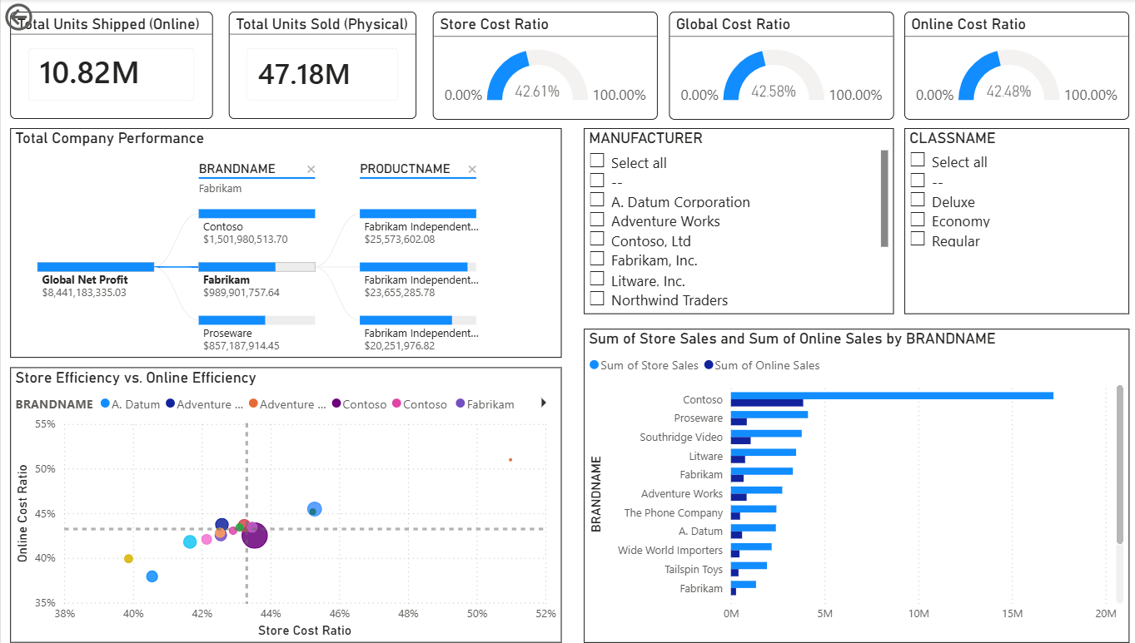

**Objective:** The objective of this analysis was to evaluate the performance of Contoso's Online versus Physical sales channels by Volume, Cost Efficiency, and Brand Profitability to identify operational bottlenecks and allocate supply chain resources to the most profitable channels for the Operations Manager.

**Dashboard Component Analysis:**

**1. Key Performance Indicators (KPIs): The Operational Health Check**

The top deck of the dashboard serves as the "Command Center" for the Operations Manager, instantly comparing the scale and efficiency of the two sales channels.

**Card 1 & 2: Volume Comparison (Total Units)**

* **Current Value:** Online (10.82M) vs. Physical (47.18M).
* **Definition:** The total count of physical items processed, packed, and handed to customers across both channels.
* **Significance for Ops Manager:** This measures **"Operational Load."** It reveals the physical stress on the supply chain.
* **Insight:** We are still a **"Retail-First" company**. Physical stores handle ~81% of our volume. This means any "Global" logistics decision must prioritize Store Replenishment over Last-Mile Delivery, as that is where the bulk of our inventory moves.

**Card 3, 4, & 5: Cost Efficiency Ratios**

* **Current Value:** Global (42.58%), Store (42.61%), Online (42.48%).
* **Definition:** A calculated efficiency metric: (Total Cost / Total Revenue). A lower percentage is better.
* **Significance for Ops Manager:** This is the primary measure of **"Spend Efficiency."** It answers: "For every dollar of revenue, how many cents do we burn on costs?"
* **Insight:** Surprisingly, **Online is slightly more efficient (42.48%) than Stores (42.61%).**
  + Strategic Implication: Typically, online shipping is expensive due to "last-mile" courier costs. The fact that our Online ratio is *lower* suggests our warehouses are highly optimized. We should feel confident expanding the Online channel as it is not eroding our margins.

**2. The "Root Cause" Analyzer (Decomposition Tree)**

* **Visual Type:** AI Decomposition Tree.
* **Metric Analyzed:** Global Net Profit ($8.44bn).
* **Breakdown Dimensions:** BrandName $\rightarrow$ ProductName.
* **Strategic Purpose:**This tool allows the manager to ignore the "noise" of thousands of products and strictly follow the money. It separates the "Vital Few" from the "Trivial Many" (Pareto Principle).
* **Key Insight from Dashboard:**The tree reveals that **Contoso** and **Fabrikam** are the "Engine Room" of the company, generating the vast majority of the $8.44bn profit.
  + Action: Supply chain risks must be managed here first. If Contoso runs out of stock, the global profit collapses. Smaller brands like "Southridge Video" are negligible risks by comparison.

**3. Store Volume and Online Volume by Brand Name (Clustered Bar Chart)**

* **Visual Type:** Clustered Bar Chart.
* **Metric Analyzed:** In-Store Volume vs. Online Volume (Grouped by Brand).
* **Strategic Purpose:** To identify **"Channel Bias"**. Some brands sell better in person (requires shelf space), while others sell better online (requires warehouse pickers).
* **Key Insight:** **Contoso** (the top bar) is drastically unbalanced. It moves ~17M units in stores but only ~3M online.
  + Action: Do not waste online ad spend or web-warehouse space on Contoso. It is a "brick-and-mortar" brand. Instead, allocate shelf space in physical retail locations to maximize its natural strength.

**4. The "Efficiency Matrix" (Scatter Plot)**

* **Visual Type:** Scatter Plot with Average Reference Lines (Quadrants).
* **X-Axis:** Store Cost Ratio (Physical Efficiency).
* **Y-Axis:** Online Cost Ratio (Digital Efficiency).
* **Strategic Purpose:** This is the "Exception Detector." It visually plots every brand's performance against the company average.
  + **Bottom-Left (Stars):** Low Cost in both channels.
  + **Top-Right (Problem Children):** High Cost in both channels.
* **Key Insight:** Most brands cluster tightly around the center (the average). However, the **Orange Dot (likely Adventure Works)** in the bottom left is a "Star"—it is cheaper to sell than anyone else.
  + Investigation: The Ops Manager should interview the Adventure Works team to see what they are doing right (e.g., smaller packaging, bulk shipping) and replicate that process for the "Problem" brands in the top right.

**5. Interactive Controls (Slicers)**

* **Visual Type:** Multi-Select Filter Panels.
* **Dimensions Controlled:** Manufacturer (Brand) and Class Name (Product Tier).
* **Strategic Purpose:** These controls transform the dashboard from a static report into a dynamic "Investigation Tool." They allow the Operations Manager to isolate specific segments of the business.
  + **Manufacturer Slicer:** Used to filter the entire view to a specific supplier (e.g., "Show me only *Fabrikam* performance"). This is critical for vendor negotiation meetings.
  + **Class Name Slicer:** Used to segment products by quality tier ("Deluxe" vs. "Economy").

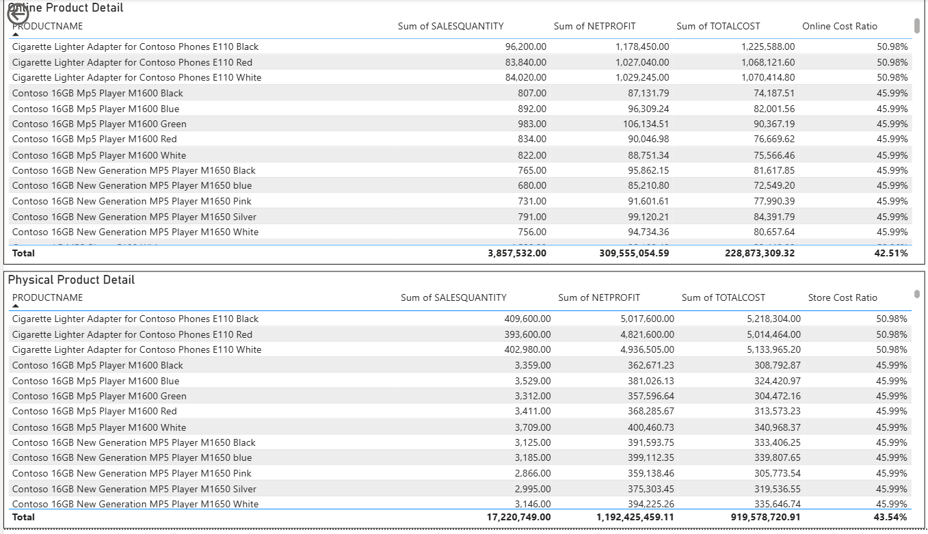

**6. Page 2: The "Deep Dive" Drill-Through**

* **Visual Type:** Detailed Data Tables (Online vs. Physical).
* **Columns Analyzed:** Sales Quantity, Net Profit, and specific Cost Ratios per Product.
* **Strategic Purpose:** Once the Manager spots a problem on Page 1 (e.g., "Why is Contoso's Cost Ratio rising?"), they drill through to this page to find the specific SKUs responsible.
* **Key Insight from Visual:** Sorting by "Cost Ratio" reveals that accessory items under contoso like the **"Cigarette Lighter Adapter"** are running at a **~51% Cost Ratio**, whereas premium items like the **"MP5 Player"** run at **~46%**.
  + Conclusion: Low-value accessories are eating up our margins. They cost too much to handle relative to their price.
  + Action: We should consider bundling these accessories with larger items rather than selling them individually to reduce the operational overhead per unit.

**For Chief Financial Officer (CFO)**

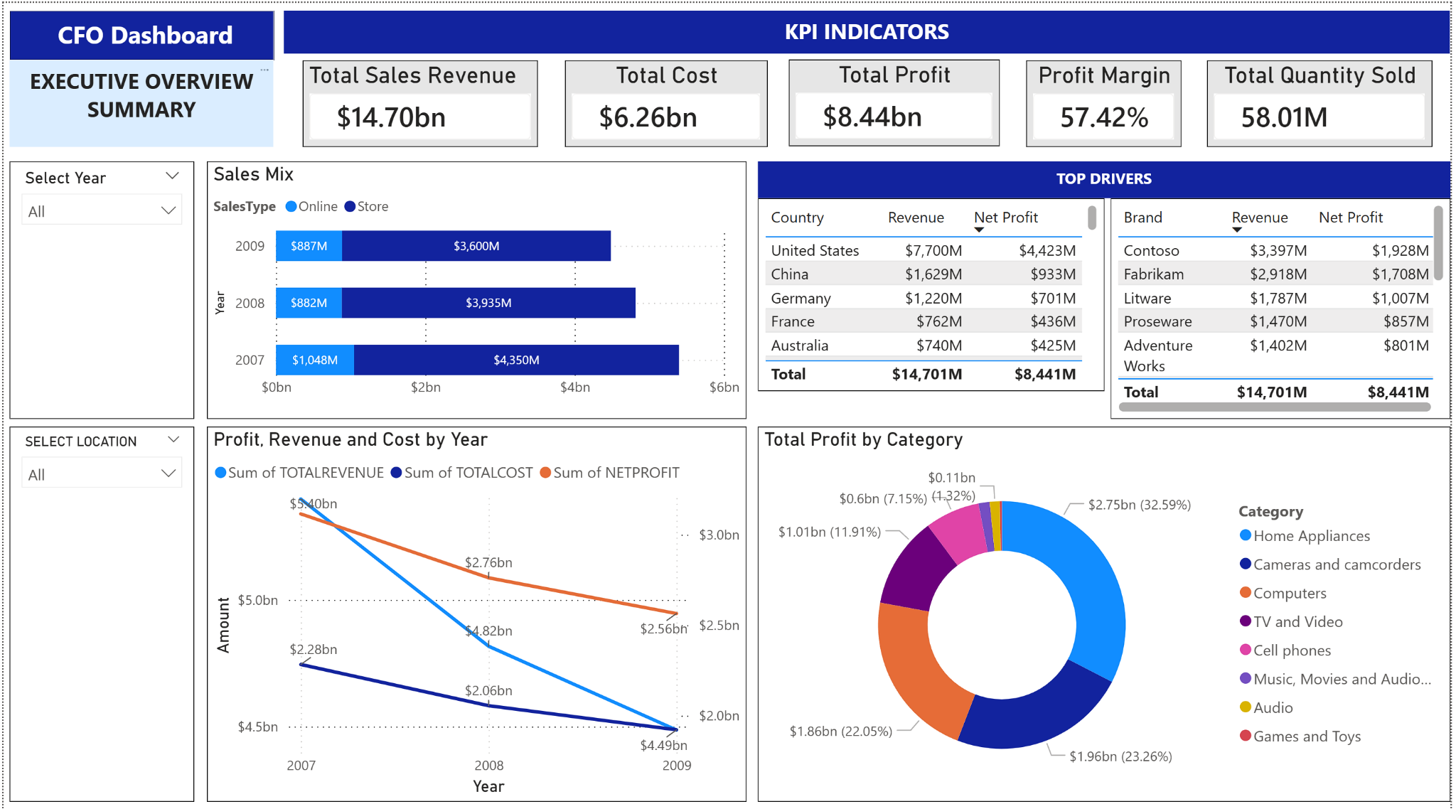

**Dashboard Overview**

I developed a **CFO Executive Summary** dashboard in **Microsoft Power BI** to support finance leadership decision making. The dashboard consolidates top line performance and profitability into a single page, and it enables quick drill-down using interactive slicers for **Year** and **Location**. The overall design focuses on answering CFO level questions quickly: current business performance, changes across time, and which dimensions are driving revenue and net profit.

**User story addressed:** As the **Chief Financial Officer (CFO)**, I want a clear executive view of revenue, cost, profit and the key drivers by channel, geography, brand and category, so that I can prioritise resources and respond quickly to business changes.

**Key Metrics**

The dashboard presents a set of **Key Performance Indicators (KPI)** as headline metrics:

* **Total Sales Revenue:** $14.70bn
* **Total Cost:** $6.26bn
* **Total Profit:** $8.44bn
* **Profit Margin:** 57.42%
* **Total Quantity Sold:** 58.01M

To support analysis behind these KPI values, the dashboard includes:

* **Sales Mix (Online vs Store) by Year** to compare channel contribution across 2007 to 2009.
* **Profit, Revenue and Cost by Year** to understand performance trends over time.
* **Top Drivers tables** for **Country** and **Brand**, showing which segments contribute the most to revenue and net profit.
* **Total Profit by Category** to highlight which product categories contribute most to overall profitability.

**Business Value**

This dashboard meets reporting needs by providing:

* **Fast executive visibility:** CFO users can understand overall performance in seconds using the KPI strip, instead of reading multiple reports.
* **Driver based decision support:** By identifying top performing countries, brands, and categories, the dashboard supports decisions such as budget allocation, prioritising key markets, and evaluating product portfolio focus.
* **Trend awareness:** The year based trend chart helps stakeholders detect changes across time and decide where deeper investigation is required.
* **Self service drill down:** With slicers for Year and Location, stakeholders can adjust scope without needing a separate report, which reduces reporting friction and speeds up decision making.

**Unique Insights**

From the default view of the dashboard:

* **Profitability is strong overall** with a **57.42%** profit margin, indicating high profit generated relative to revenue at the aggregated level.
* **The business is highly concentrated in one market.** The **United States** contributes **$7,700M** revenue and **$4,423M** net profit, which is about **52%** of the totals shown. This highlights both an opportunity (largest driver) and a concentration risk (heavy dependency).
* **A few brands drive a large share of results.** For example, **Contoso ($3,397M revenue, $1,928M net profit)** and **Fabrikam ($2,918M revenue, $1,708M net profit)** are leading drivers, suggesting brand level portfolio prioritisation can have a significant impact.
* **Profit is not evenly distributed across categories.** **Home Appliances** is the largest profit contributor at **$2.75bn (32.59%)**, meaning category strategy can materially influence total profitability.
* **Channel mix matters.** The Sales Mix chart shows **Store** consistently contributes more revenue than **Online**, implying that store performance has a larger influence on overall outcomes and should be monitored closely.

## 2.7.2 Dashboard Utilisation Report for Key Business Roles

The set of dashboards developed provides a comprehensive view of sales, customers, profitability, and operational performance. These dashboards transform raw data into actionable insights that support data-driven decision-making across multiple managerial roles. Each role benefits differently based on their responsibilities and strategic focus.

### **1. Regional Sales Manager**

The Regional Sales Performance dashboard helps regional managers monitor sales performance across locations and time.

**How it helps:**

* Tracks **regional revenue trends** over time
* Compares performance between countries, cities, and stores
* Identifies **top-performing stores**
* Highlights underperforming regions needing attention

**Business Value:**

This enables regional managers to allocate resources effectively, adjust local strategies, and set realistic sales targets. It also supports expansion planning and performance benchmarking across regions.

### **2. Customer Analyst**

The Customer Segmentation & Revenue Analysis dashboard supports customer-focused decision-making.

**How it helps:**

* Segments customers by **gender, education, and occupation**
* Identifies **high-value customer groups**
* Monitors revenue contribution by customer segments
* Detects churn or lower-spending groups

**Business Value:**

Customer analysts can design targeted marketing campaigns, improve retention strategies, and personalise offers. This leads to better customer satisfaction and higher lifetime value.

### **3. Operations Manager**

The operations-focused dashboard (sales units, cost ratios, efficiency metrics) supports operational monitoring.

**How it helps:**

* Tracks **units sold (online vs physical)**
* Monitors **store and global cost ratios**
* Evaluates store efficiency
* Identifies operational bottlenecks

**Business Value:**

Operations managers can optimise inventory, control costs, and improve store efficiency. This ensures smoother operations and better resource utilisation.

### **4. Product Owner**

The Product Profitability & Performance dashboard provides insights into product success.

**How it helps:**

* Shows **profit margins by product and category**
* Identifies **top and bottom performing products**
* Compares revenue vs sales volume
* Highlights profitable product lines

**Business Value:**

Product owners can prioritise high-performing products, discontinue low-margin items, and plan pricing strategies. This improves product portfolio performance and profitability.

### **5. Chief Financial Officer (CFO)**

The CFO dashboard offers a high-level financial overview.

**How it helps:**

* Displays **total revenue, cost, and profit**
* Shows **profit margins and total quantity sold**
* Provides financial trends and KPIs
* Enables quick financial health assessment

**Business Value:**

CFOs can monitor financial performance, support budgeting decisions, and ensure profitability targets are met. It supports strategic planning and financial risk management.

# 2.8: Burn Down Charts by Sprint

Throughout the project lifecycle, the team utilized Burn Down charts to track the completion of User Stories against our estimated timeline. The following analysis details our progression from initial estimation struggles to a predictable Agile velocity.

## Sprint 1: Foundation & Setup

* **Goal:** Establish the project infrastructure (GitHub, Trello, Snowflake) and justify the dataset selection.
* **Total Story Points:** 15 SP
* **Dates:** 5 December – 14 December

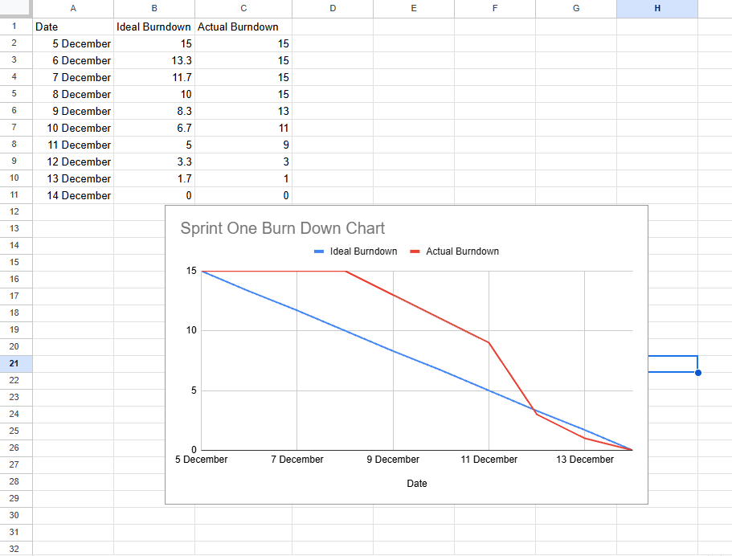

Sprint 1 took place from **5 December to 14 December** with a total of **15 Story Points**. The main goal of this sprint was to set up the project foundation, such as **GitHub and Trello for team coordination, Snowflake for the data platform**, and to justify the dataset chosen for the project.

From the burn down chart, the **Ideal Burndown** shows a steady decrease in remaining work, while the **Actual Burndown** stays flat at the start of the sprint. This is because most tasks in Sprint 1 involved setup and planning, where progress is not immediately reflected as completed story points. Once these setup tasks were finalised, there was a faster drop in remaining work, showing that the team was able to complete tasks more efficiently.

By **14 December**, all **15 story points were completed**, and the sprint goal was achieved. This sprint was also planned to be shorter as it was during **Common Test Week**, allowing the team to balance revision time while still making steady progress. Overall, the chart shows that the team managed their time well and successfully completed the sprint despite academic constraints.

## Sprint 2: Ingestion & Modeling

* **Goal:** Load the massive transaction tables (FactSales) and build the core SEA data models.
* **Total Story Points:** 20 SP
* **Dates:** 15 December – 4 January

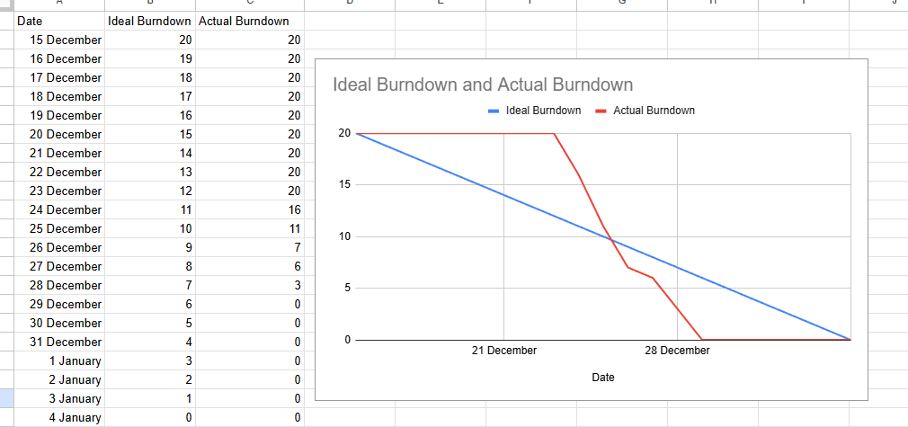

Sprint 2 ran from **15 December to 4 January** with a total of **20 Story Points**. The main goal was to **load the large FactSales tables, complete all dimension tables, and build the core SEA data models** in Snowflake.

The **Actual Burndown** stays flat at the start of the sprint, as early tasks involved loading and validating **millions of records** and resolving table dependencies, which could not be marked as done immediately. Once the core Fact and Dimension tables were successfully loaded and validated, there was a **sharp drop in remaining story points**, showing faster task completion for dependent work such as creating master views, SEA-specific views, and integrity checks.

Even though the sprint overlapped with the **Christmas period**, all **20 story points were completed** with no backlog items carried forward. Overall, the burndown chart shows effective planning, good team coordination through daily stand-ups, and successful delivery of the Sprint 2 objectives.

## Sprint 3: Trusted Reporting Layer

* **Goal:** Finalize the trusted layer by cleaning data anomalies, verifying integrity, and establishing BI connectivity.
* **Total Story Points:** 27 SP
* **Dates:** 7 January – 18 January

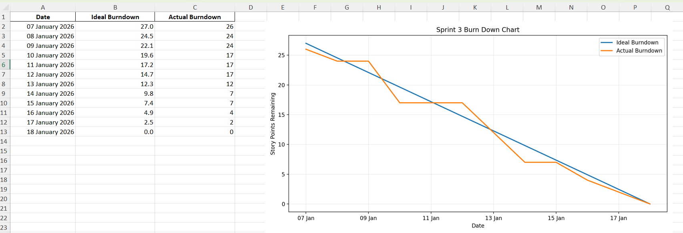

Sprint 3 was carried out from **7 January to 18 January** with a total of **27 Story Points**. The goal of this sprint was to **finalise the Trusted Reporting Layer** by cleaning data anomalies, validating data integrity, and ensuring stable **Power BI connectivity** to Snowflake.

From the burn down chart, the **Actual Burndown** generally follows the **Ideal Burndown**, with some periods of slower progress at the start of the sprint. This was expected, as many early tasks involved **data validation, reconciliation checks, and integrity testing**, which required coordination across multiple team members before work could be marked as completed.

A more noticeable reduction in remaining story points occurs in the middle to later part of the sprint, once cleaning logic, duplicate handling, and integrity checks were confirmed to be correct. This allowed reporting views to be finalised and BI connectivity preparation to proceed smoothly. By **18 January**, all **27 story points were completed**, and no backlog items were carried forward.

Overall, the burndown chart shows steady progress despite the technical complexity of Sprint 3. It reflects good collaboration during daily stand-ups and successful delivery of a trusted and validated reporting layer, which unblocked dashboard development for the next sprint.

## Sprint 4: Business Intelligence & Dashboarding

* **Goal:** Transform the trusted data warehouse into actionable Power BI dashboards for five distinct user personas.
* **Total Story Points:** 21 SP
* **Dates:** 19 January – 25 January

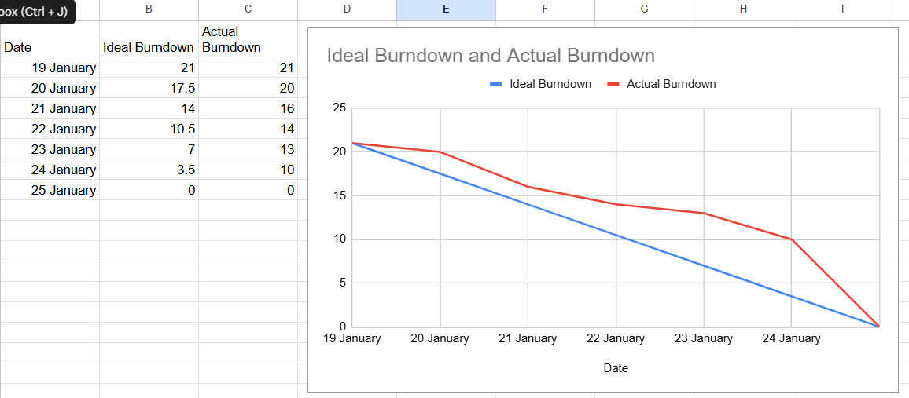

Sprint 4 ran from **19 January to 25 January** with a total of **21 Story Points**. The objective of this sprint was to **convert the trusted data warehouse into actionable Power BI dashboards** for five different user personas, including executive, regional, product, marketing, and operations roles.

From the burn down chart, the **Actual Burndown** shows a slower reduction in the early part of the sprint. This was partly due to the **iterative nature of dashboard development**, where visuals and insights required multiple refinements before completion. In addition, a technical blocker was encountered when connecting **Power BI to Snowflake**, caused by **multi-factor authentication (MFA) and role-based access restrictions**, which temporarily delayed progress for some team members.

Once the connectivity issue was resolved by configuring appropriate roles and authentication access, progress accelerated and remaining dashboard tasks were completed. By **25 January**, all **21 story points were successfully completed**, with no backlog items carried forward.

Overall, the burndown chart reflects effective problem-solving, good communication during daily stand-ups, and successful completion of Sprint 4 goals, allowing Sprint 5 to focus solely on final report compilation and refinement.

## Sprint 5: Final Report & Presentation

* **Goal:** Compile and finalise the Assignment 2 report and presentation.
* **Total Story Points:** 25 SP
* **Dates:** 26 January – 30 January

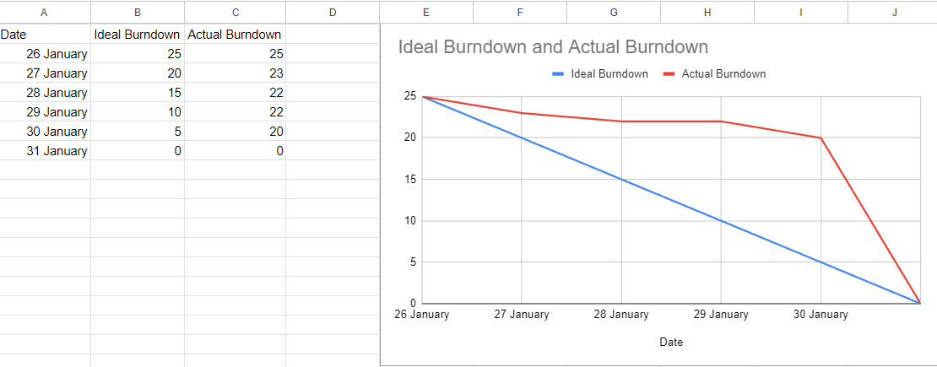

Sprint 5 took place from **26 January to 30 January** with a total commitment of **25 Story Points**. The goal of this sprint was to collaboratively compile, finalise, and prepare the Assignment 2 report and presentation for submission.

From the burndown chart, the **Actual Burndown remains close to the initial level during the early part of the sprint**, as most tasks involved documentation, integration, and coordination across team members. These activities required multiple sections to be completed and reviewed before they could be marked as done, resulting in slower visible progress at the start.

A **sharp drop in remaining story points occurs near the end of the sprint**, reflecting the completion of consolidated report sections and presentation materials once all individual contributions were finalised. This pattern is expected for a final compilation sprint, where work completion is highly interdependent.

By **30 January**, all **25 story points were completed**, and the sprint goal was successfully achieved. Overall, the burndown chart shows effective coordination, clear task ownership, and timely completion of deliverables, allowing the team to submit a cohesive final report and presentation without any carry-over work.

# 2.9: Challenges and Solutions

This section documents the primary technical and team-dynamic hurdles encountered during the project and the Agile strategies employed to resolve them.

## Technical Challenge 1: Snowflake 2FA & Power BI Connectivity

* **The Issue:** At the start of Sprint 4, the team encountered a "Blocking" security issue when connecting Power BI to the **DW_CONTOSO** database. Because our Snowflake environment enforces **Two-Factor Authentication (2FA)**, the standard Power BI connector failed to authenticate.
* **The Impact:** This completely blocked the Dashboarding phase. The dashboard designers could not import the live data, threatening to delay the entire sprint deliverables since no visualizations could be built without the live connection.
* **The Solution:** We pivoted from standard password authentication to **Key Pair Authentication**, a more secure enterprise standard.
  1. **Key Generation:** We utilized Git Bash and OpenSSL to generate a 2048-bit RSA Private and Public Key pair.
  2. **Snowflake Configuration:** The team Admin (Wei Xian) executed an ALTER USER SQL command to assign the generated Public Key to the Snowflake user account.
  3. **Outcome:** Power BI authenticated directly using the private key, bypassing the MFA prompt. We successfully established a stable, secure gateway for all 5 user personas without disabling security protocols.

## Technical Challenge 2: Mitigating Row Inflation & Revenue Discrepancies

* **The Issue:** During the initial validation of the Star Schema (Task 3.3), we identified a critical risk of "Row Inflation" (Fan-out), where Many-to-Many relationships could accidentally duplicate fact rows. Additionally, the raw legacy data contained "Orphan Records"—transactions pointing to Product Keys that did not exist in the Dimension tables.
* **The Impact:** This caused a discrepancy between the source system revenue and our Snowflake views. If left unaddressed, this would have resulted in **inflated financial reporting** (double-counting revenue) and broken drill-down functionality.
* **The Solution:** We implemented a strict **Post-Load Integrity Protocol**:
  1. **Grain Definition:** We formally defined the grain (Task 3.3.1) to ensure joins utilized the correct Primary Keys (SalesKey vs SalesOrderNumber).
  2. **Strict Joins:** We utilized INNER JOIN logic to enforce Referential Integrity, automatically rejecting orphan records rather than keeping them as NULLs.
  3. **Reconciliation Bridge:** We wrote a validation script (Task 3.3.5) to confirm that Raw Revenue - Orphan Revenue = Actual View Revenue.
* **The Outcome:** We successfully prevented row inflation (**0 duplicates confirmed**) and verified that all excluded revenue was legitimately invalid data. This ensured the dashboard presents a "Clean" view of the business without inflating figures or showing broken relationships.

## Technical Challenge 3: GitHub Access Control and Repository Governance

**The Issue:** During Sprint 2 and Sprint 3, the team initially worked from a private repository owned by an Jayden. This setup limited administrative access, making it difficult to grant all members appropriate permissions for branch management, pull requests, and repository configuration.

**The Impact:** Restricted access created a risk to collaboration and workflow continuity. Tasks such as managing branches, updating repository settings, and maintaining consistent version control could not be performed equally by all team members, increasing dependency on a single owner and introducing a potential single point of failure.

**The Solution:** To resolve this, the team migrated the project into a dedicated GitHub Organization repository. A new organization was created under a neutral group identity, and a private repository was initialized within it. Repository ownership and administrative permissions were then properly distributed by assigning members repository-level admin rights without granting full organization ownership.

**Migration & Validation:** The existing repository was migrated using a mirror push, preserving full commit history, branches, and tags. Authentication succeeded without additional credential prompts due to cached credentials from prior secure key-based configuration. Post-migration verification confirmed that all branches were intact and accessible.

**The Outcome:** This change established proper governance, eliminated access bottlenecks, and ensured equal collaboration across the team. The organization-based repository also improved traceability, auditability, and alignment with enterprise-style DevOps practices.

## Team Dynamic Challenge: Task Dependencies in Thematic Sprints

* **The Issue:** Our project followed a "Thematic Sprint" structure (e.g., Sprint 2 was entirely Data Loading). While this focused the team, it created high internal dependency. Because everyone was working on the same layer of the stack simultaneously, one member's delay often acted as a direct blocker for another teammate within the same sprint.
* **The Impact:** This led to significant "Wait Time." For example, during Sprint 2 (Ingestion), **Simon** could not finish creating the Master View because he was waiting for **Shao En and Wei Xian** to finish loading the underlying Dimension tables. This lack of synchronization caused work to stall.
* **The Solution:** As Scrum Master, I implemented specific process changes to mitigate these dependency blockers:
  1. **Bi-Daily Stand-ups:** We instituted a mandatory sync **every 48 hours** to ensure blockers were flagged immediately.
  2. **Critical Path Awareness:** We prioritized "Blocker Tasks" (prerequisites) to be started on Day 1 of the sprint.
  3. **Standardized Verification:** We enforced a strict "Definition of Done" requiring proper verification formats (e.g., row counts) before a task was closed.
* **The Outcome:** By Sprint 3, the "Wait Time" between handoffs was reduced significantly. The standardized verification meant downstream members no longer had to waste time fixing upstream errors, allowing us to deliver Sprint 4's dashboards with zero carry-over tasks.

## Problem-Solving Approach

Throughout the project, the team applied **technical, analytical, and operational problem-solving** to overcome challenges without compromising system integrity or project timelines. Rather than relying on temporary workarounds, issues were addressed by identifying root causes, redesigning affected components, and validating solutions with measurable evidence.

Technical issues were resolved through secure system configuration and integration redesign, while data-related problems were addressed using SQL-based validation and reconciliation. Operational challenges were mitigated by restructuring task execution order and enforcing clear verification standards. This problem-solving approach ensured that solutions were scalable, auditable, and suitable for enterprise-level data operations.

# 2.10: Reflection and Lessons Learned

## Agile Methodology

Working in sprints helped our team stay organised and avoid rushing everything at the end. Using Trello with clear user stories and story points made it easier to track progress and see what was stuck. Daily stand ups were especially useful for surfacing blockers early, such as table dependency issues during data ingestion and the Power BI to Snowflake connection problem caused by multi factor authentication. Over time, we became more consistent in following a clear Definition of Done, such as including validation queries and evidence screenshots, which reduced rework and improved the reliability of our final reporting layer.

## Personal and Team Growth

As a team, we learned that DataOps is not only about loading data, it also requires discipline in validation, documentation, and collaboration. Technically, we gained stronger skills in cloud data warehousing and analytics engineering, including star schema modelling, handling data anomalies like placeholder values and duplicates, and running integrity checks such as row count comparisons and revenue reconciliation. We also became more confident using industry practices like version control in GitHub, structured script execution order, and secure authentication through key pair setup to support BI connectivity without lowering security. As a group, we improved communication by managing task dependencies better and prioritising prerequisite tasks earlier to reduce waiting time between members.

## Future Applications

This project showed us how a structured workflow can make complex data work more manageable. In future projects, we would start dependency heavy tasks earlier, define acceptance criteria more clearly during sprint planning, and treat validation scripts as a standard requirement from the beginning instead of adding them later. We would also test tool integration earlier, especially for Power BI connectivity, to avoid late stage blockers. Overall, the skills gained from this project, including Agile coordination, data quality validation, and building a trusted reporting layer, can be applied to real world analytics projects where accuracy, reproducibility, and stakeholder ready insights matter.

# 2.11 Conclusion

**Results Recap:**   
The DataOps modernization initiative successfully transformed Contoso’s fragmented, on-premises infrastructure into a scalable, cloud-native ecosystem. By migrating the core retail dataset to **Snowflake**, the team eliminated the critical performance bottlenecks that previously hampered the South East Asia expansion strategy. The implementation of a robust **Star Schema** **and ELT pipelines** achieved the primary management objective: creating a "Single Source of Truth" that handles millions of transaction rows while decoupling analytical workloads from operational systems.

**Business Impact:**   
The solution delivers transformative long-term value by shifting Contoso from reactive reporting to proactive, data-driven decision-making:

* **Operational Agility:**Regional managers across Singapore, Bangkok, and Jakarta now benchmark store and agent performance in real-time, reducing reporting latency from days to seconds and enabling rapid response to market shifts.
* **Financial Optimization:**Enhanced visibility has driven immediate ROI by identifying opportunities to liquidate underperforming inventory (legacy MP3/DVD lines) while scaling investment in high-margin categories such as Home Appliances (57.62% profit margins).
* **Architectural Scalability:**The cloud-native foundation supports Contoso's aggressive expansion roadmap, enabling seamless integration of new regional markets without infrastructure constraints or performance degradation.

**Final Thoughts:**   
The successful deployment of this Snowflake-backed analytics platform marks a pivotal step in Contoso’s digital transformation. The system is not only robust enough to handle current transaction volumes but is also future-proofed for advanced applications, such as AI-driven demand forecasting. With a solid DataOps foundation now in place, Contoso is well-positioned to maintain its competitive edge and sustain its expansion across the global electronics market.

# 2.12. References

Bhanu. (2023). *Cleaned Contoso dataset* (Version 6) [Data set]. Kaggle.<https://www.kaggle.com/datasets/bhanuthakurr/cleaned-contoso-dataset>

OpenAI. (2024). *ChatGPT* (GPT-4o model) [Large language model].<https://chatgpt.com>

Google. (2024). *Gemini* (Gemini 1.5 Pro model) [Large language model].<https://gemini.google.com>

Ang Shao En. (2025).DS*: Agile DataOps* [Course website]. Ngee Ann Polytechnic.<https://nplms.polite.edu.sg/d2l/home/802881>

Microsoft. (2025, October 14). *Connect to Snowflake in the Power BI service*. Microsoft Learn.<https://learn.microsoft.com/en-us/power-bi/connect-data/service-connect-snowflake>